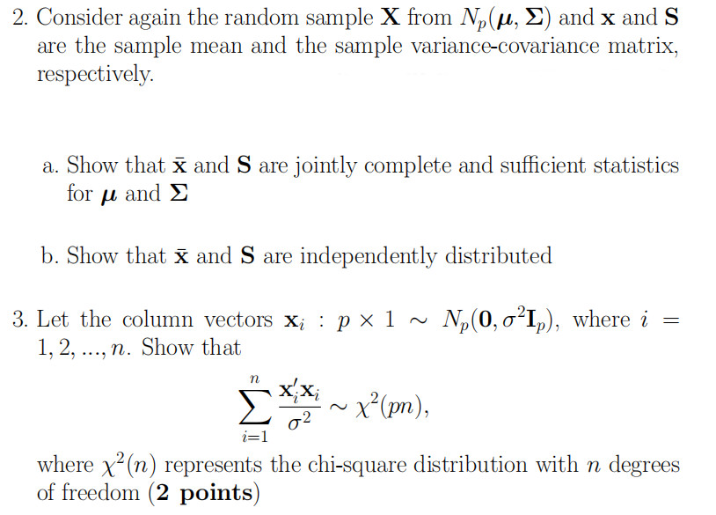

2.
(a)
$$f\left(x;θ\right)={\left(\frac{1}{{2π}^{p/2}{|Σ|}^{1/2}}\right)}^{n}\exp\left(-\frac{1}{2}\left(\sum_{i=1}^{n}{x_{i}'Σ^{-1}x_{i}}-2\sum_{i=1}^{n}{x_{i}'Σ^{-1}μ}+nμ^{'}μ\right)\right)={\left(\frac{1}{{2π}^{p/2}{|Σ|}^{1/2}}\right)}^{n}\exp\left(-\frac{1}{2}\left(\sum_{i=1}^{n}{x_{i}'Σ^{-1}x_{i}}\right)\right)∙\exp\left(\sum_{i=1}^{n}{x_{i}'Σ^{-1}μ}-\frac{n}{2}μ^{'}μ\right)$$
So, $\overline{x}$ and $S$ are sufficient statistics.
(b)
Let $z_{i}=x_{i}-μ$,for i =1,2, …, n.
Let $\overline{z}=\frac{1}{n}∙\sum_{i=1}^{n}{z_{i}}=\frac{1}{n}∙\sum_{i=1}^{n}{x_{i}}-\frac{1}{n}∙\sum_{i=1}^{n}{μ}=\overline{x}-μ$.
We have, $z_{i}\sim N_{p}\left(0, Σ\right)$ and
$Cov\left(z_{i},z_{j}\right)=\left\{\begin{matrix}0 , if i=j \\ Σ , if i≠j \end{matrix}\right.$
$$\left(n-1\right)S=\sum_{i=1}^{n}{\left(x_{i}-\overline{x}\right)\left(x_{i}-\overline{x}\right)'}=\sum_{i=1}^{n}{\left((x_{i}-μ)-(\overline{x}-μ)\right)\left((x_{i}-μ)-(\overline{x}-μ)\right)'}=\sum_{i=1}^{n}{\left(z_{i}-\overline{z}\right)\left(z_{i}-\overline{z}\right)'}=\sum_{i=1}^{n}{\left(z_{i}∙z_{i}'-\overline{z}∙z_{i}'-z_{i}∙\overline{z}'+\overline{z}∙\overline{z}'\right)}=\sum_{i=1}^{n}{z_{i}∙z_{i}'}-\overline{z}∙\sum_{i=1}^{n}{z_{i}'}-\left(\sum_{i=1}^{n}{z_{i}}\right)\overline{z}'+n∙\overline{z}∙\overline{z}'=\sum_{i=1}^{n}{z_{i}∙z_{i}'}-n∙\overline{z}∙\overline{z}'$$
Take an n-dimensional orthogonal matrix A=(a_{ij}) with all elements of the first column are $\frac{1}{\sqrt{n}}$ , Let
$$\left(y_{1},y_{2},…,y_{n}\right)=(z_{1},z_{2},…,z_{n})A$$
That is, $y_{i}=\sum_{j=1}^{n}{a_{ji}}z_{j}$ , thus we have
$E\left(y_{i}\right)=\sum_{j=1}^{n}{a_{ji}}E\left(z_{j}\right)=0$ .
$$Cov\left(y_{i},y_{k}\right)=Cov\left(\sum_{j=1}^{n}{a_{ji}z_{j}},\sum_{l=1}^{n}{a_{lk}z_{l}}\right)=\sum_{j=1}^{n}{\sum_{l=1}^{n}{a_{ji}a_{lk}Cov(z_{j},z_{l})}}=\sum_{j=1}^{n}{a_{ji}a_{jk}}=\left\{\begin{matrix}0 , if i=k \\ Σ , if i≠k \end{matrix}\right.$$
Therefore, $y_{1},y_{2},…,y_{n}$ are independently and identically distributed normal distribution random variables and $y_{i}\sim N_{p}\left(0, Σ\right)$.
$$y_{1}=\sum_{j=1}^{n}{a_{j1}}z_{j}=\sum_{j=1}^{n}{\frac{1}{\sqrt{n}}}z_{j}=\sqrt{n}\overline{z}$$
$$y_{1}∙y_{1}^{'}= n∙\overline{z}∙{\overline{z}}^{'}$$
$$\sum_{i=1}^{n}{y_{i}∙y_{i}'}=\left(y_{1},y_{2},…,y_{n}\right){\left(y_{1},y_{2},…,y_{n}\right)}^{'}=\left(z_{1},z_{2},…,z_{n}\right)A{\left(\left(z_{1},z_{2},…,z_{n}\right)A\right)}^{'}=\left(z_{1},z_{2},…,z_{n}\right){AA}^{'\left(z_{1},z_{2},…,z_{n}\right)'}=\sum_{i=1}^{n}{z_{i}∙z_{i}'}$$
$$\left(n-1\right)S=\sum_{i=1}^{n}{z_{i}∙z_{i}'}-n∙\overline{z}∙{\overline{z}}^{'}=\sum_{i=1}^{n}{y_{i}∙y_{i}'}-y_{1}∙y_{1}^{'}=\sum_{i=2}^{n}{y_{i}∙y_{i}'}$$
Because
$$\overline{x}=\overline{z}+μ=\frac{y_{1}}{\sqrt{n}}+μ$$
and
$$S=\frac{1}{n-1}∙\sum_{i=2}^{n}{y_{i}∙y_{i}'}$$
$\overline{x}$ only depends on $y_{1}$ , while $S$ only depends on $y_{2},y_{3},…,y_{n}$. We can conclude that $\overline{x}$ and $S$ are independently distributed.

3.
Let $x_{i}=\left(\begin{matrix}x_{i}^{1} \\ \begin{matrix}x_{i}^{2} \\ …\end{matrix} \\ x_{i}^{p}\end{matrix}\right)$. Since $x_{i}\sim N_{p}(0,σ^{2}I_{p})$, $x_{i}^{1}$, $x_{i}^{2}$, …, $x_{i}^{p}$ are independently and identically distributed normal distribution random variables. $x_{i}^{j} \sim N(0, σ^{2})$ for j = 1, 2, …, p. So $\frac{x_{i}^{j}}{σ} \sim N(0, 1)$
Therefore,
$$\sum_{i=1}^{n}{\frac{x_{i}'x_{i}}{σ^{2}}}=\sum_{i=1}^{n}{\sum_{j=1}^{p}{\frac{{x_{i}^{j}}^{2}}{σ^{2}}}}$$
According to the definition of chi-square distribution, we have
$$\sum_{i=1}^{n}{\frac{x_{i}'x_{i}}{σ^{2}}}\sim χ^{2}(pn)$$

