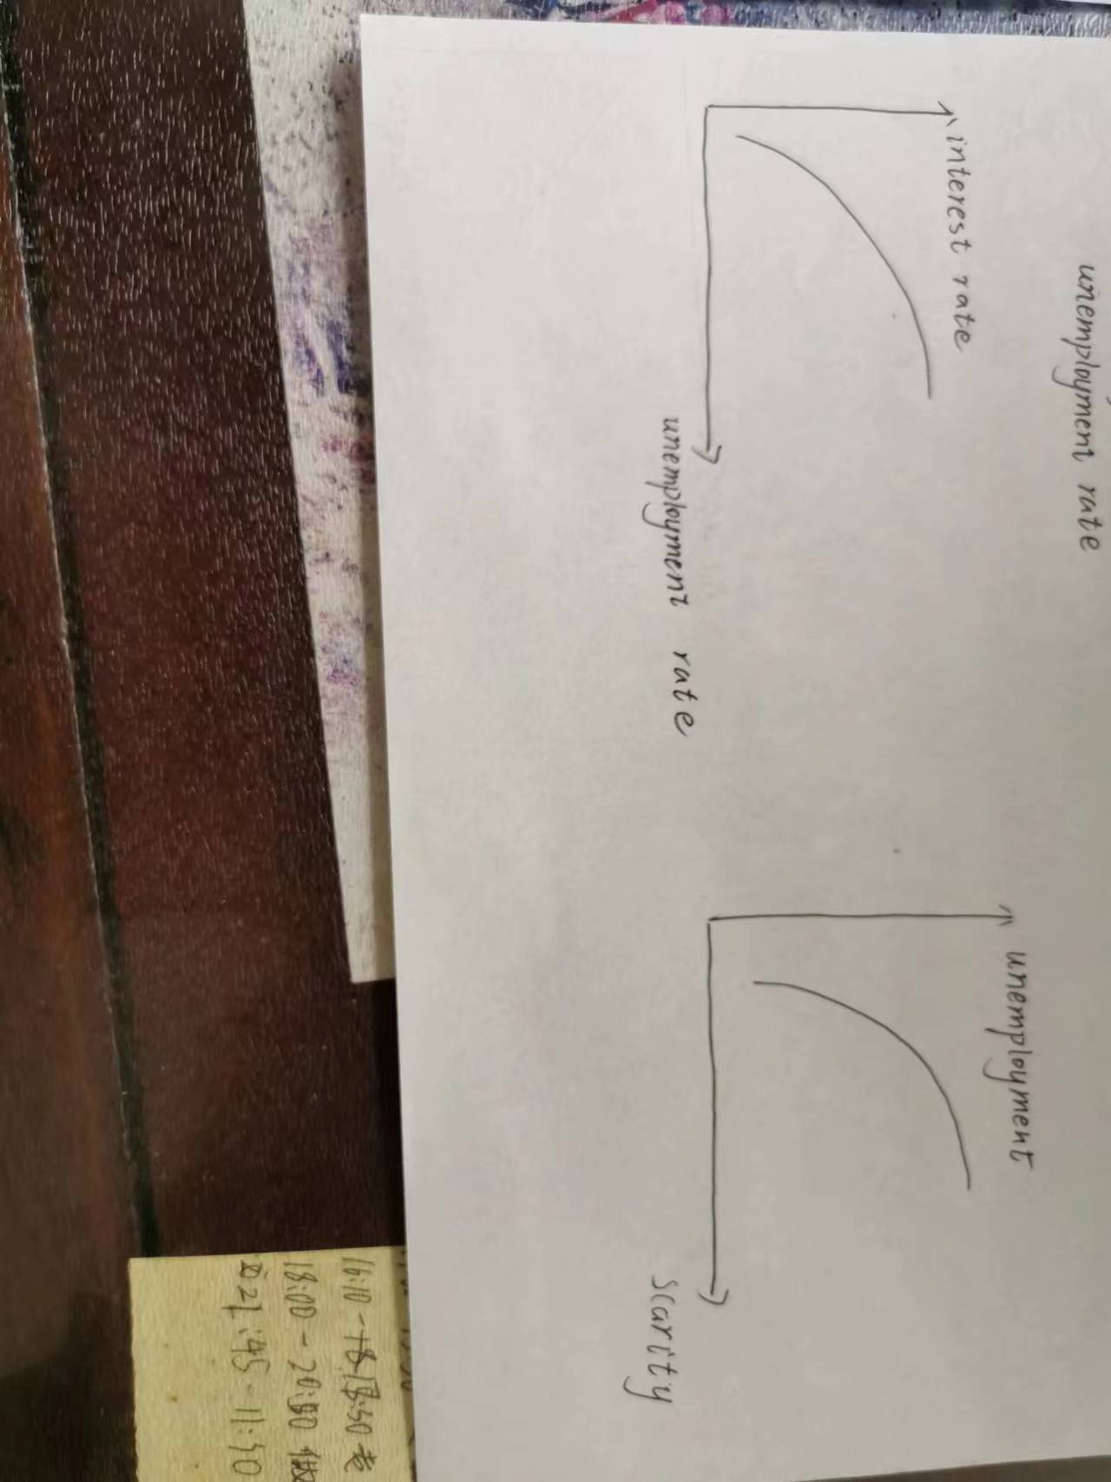
Figure 1: The horizontal axis is the unemployment rate, and the vertical axis is the interest rate. The unemployment rate is positively correlated with the interest rate.
Federal Reserve officials believe that the unemployment rate is proportional to the interest rate. When the unemployment rate rises, the Federal Reserve needs to cut interest rates in order to stimulate the economy. The underlying economic law behind this is that low interest rates can reduce unemployment. However, we should note that from the perspective of priority, the recent reality is that the lower unemployment rate makes the Federal Reserve think there is room to raise interest rates, and the lower unemployment rate will lead to higher interest rates.
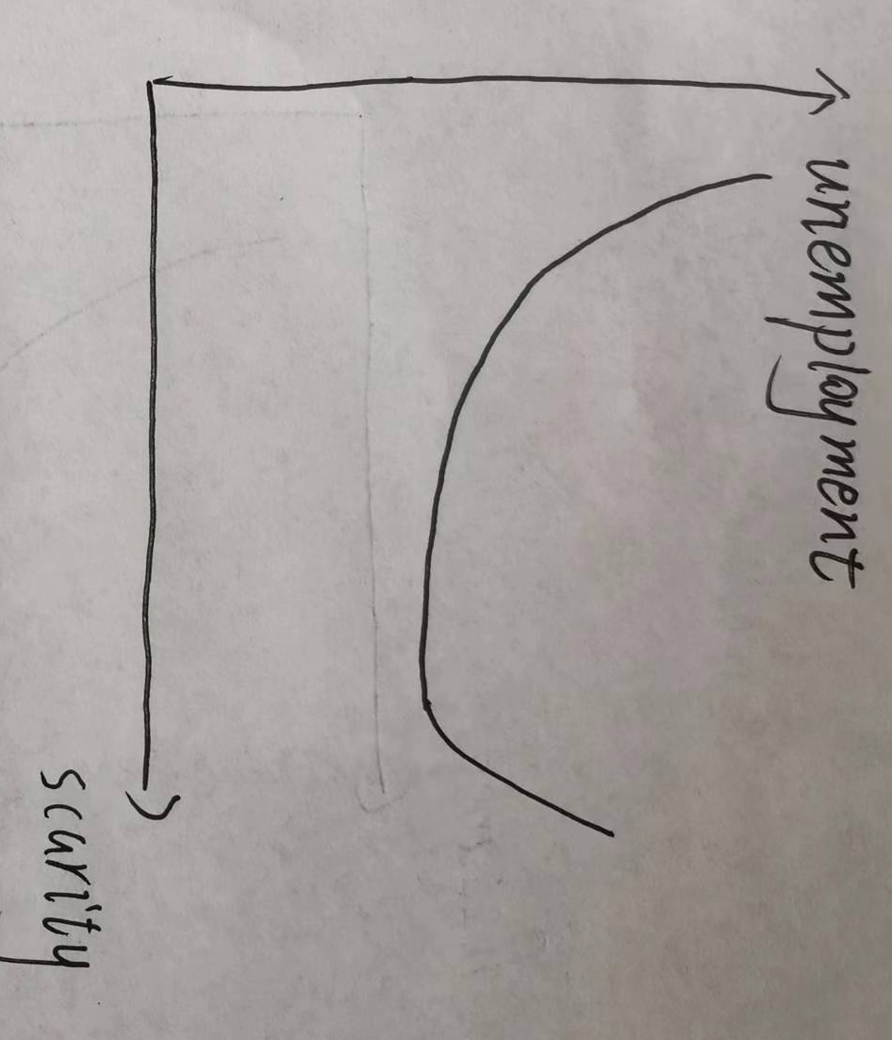
Figure II: the horizontal axis is the shortage of labor, the vertical axis is unemployment rate, and the relationship between the two is first negatively and then positively related.
When labor is deficient, employers raise wages, which leads to a decrease in the unemployment rate. But employers are limited to pay increases, which stop when costs exceed prices. And, raising wages leads to higher prices, which in turn leads to inflation. This forced the Federal Reserve to raise rates, ultimately leading to a higher unemployment rate.

