- Rivalry: The bearing capacity of the playground is limited, and it can not bear all families.
Exclusion: Although everyone pays the cost, families far away cannot use the playground for entertainment.

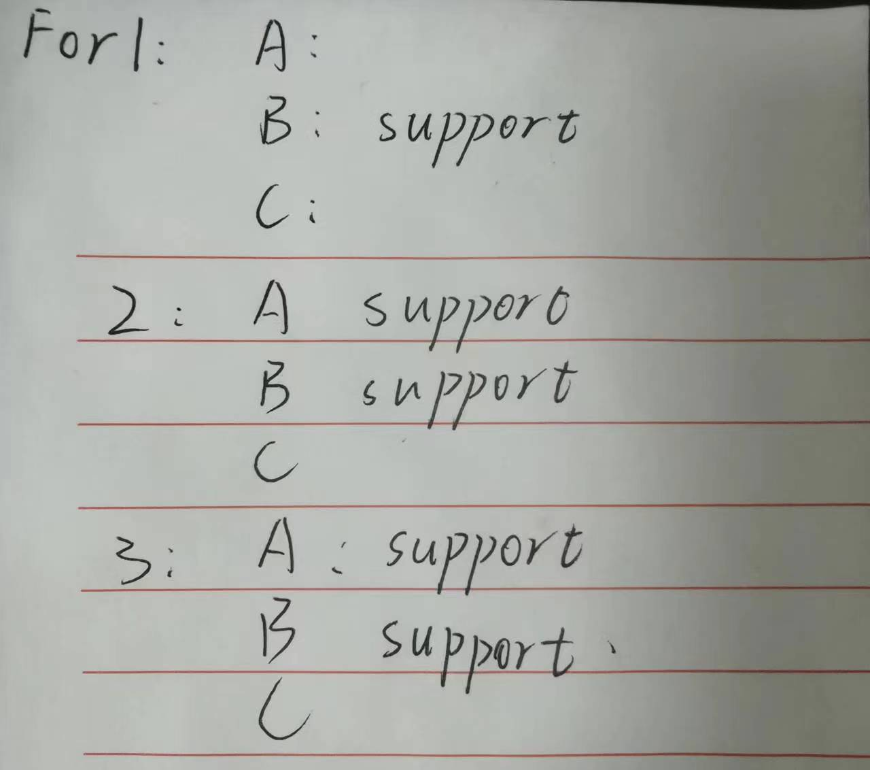
Both positions 2 and 3 will be supported by two families, but for family B, position 2 is better, so they will vote for position 2. The playground will be installed in position 2. The result is not valid. Because the total yield for the 3 families is highest when the operon is established at position 1.
- C-G: The tax each family would be willing to cross over to each location for its own utility.
For position 1, 1500 are quoted for family a, 5000 for family B, and 1000 for family C.
For position 2, family a was quoted as 2000, family B as 3000, and family C as 1000.
For position 3, 2000 were quoted for family a, 2200 for family B, and 1000 for family C.
A tax of 7500 will eventually be raised.
- This mechanism internalizes the externality of each participant, exposing him to self-reported utility and the costs and benefits imposed by all others. The more tax and Pareto optimal results manifest themselves on specific issues.

