Q1
1a
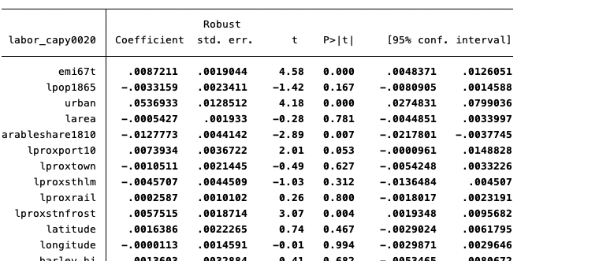
The coefficient for emigration is 0.0087 and is significant at 0.05.
We clustered at the weather station level since municipalities’ labor organization rates may be correlated within weather stations.

1b
No. Emigration can still correlated with error term, the unobserved characteristics.

1c
Assumption1: the instrument variable is correlated with emigration.
Assumption2: the instrument variable do not have a direct effect on political outcomes

1d
Yes, instrument is uncorrelated with all but log population in 1865. It support the assumption 2 in c: IV is uncorrelated with variables that can affect outcome variables. ***in order to look similar to the paper, I also add fixed effect and cluster se.

1e
First stage
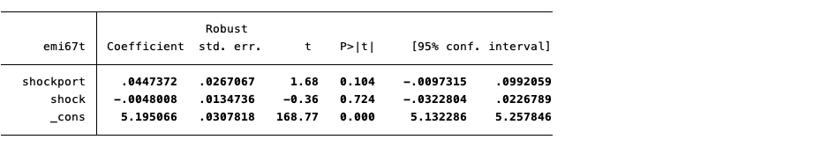
Second stage
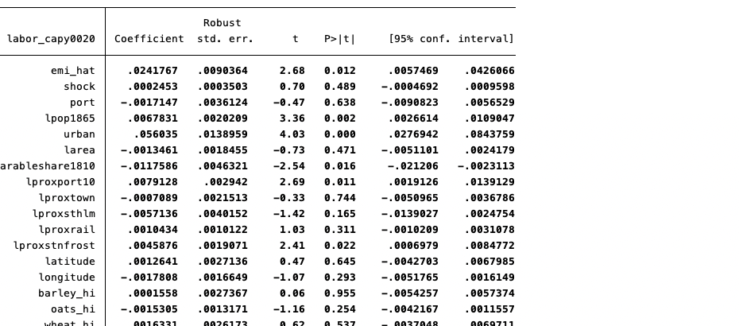

1f
IV coefficient is .0242 and significant.
OLS coefficient is .0087 and significant.
IV coefficient is larger.

1g
Since frost shock and distance to port is correlated with some control variables, such as wheat and proximity to town, thus if not being included, will have the omitted variables problem.

1h
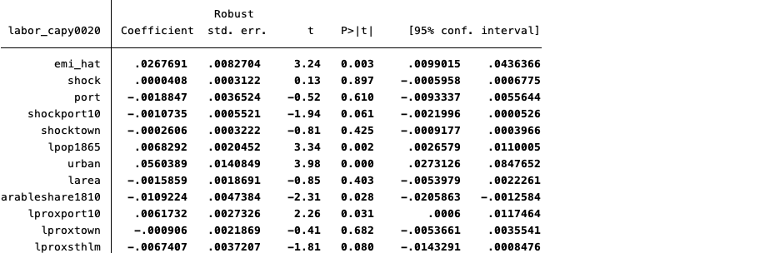
We may want to include these two controls since we want our IV be random after conditioning on some observable variables. Since these two interactions are correlated to shock*port, and if they have an effect on the outcome, not including them will cause the IV not exogeneous.
Yes the result is robust with additional controls: coefficient of emi_hat is still significant and at around 0.25.

Q2
2a
To be unbiased:
Assumption: those individuals immediately younger than 40 should have the same distribution of the unobserved variables as those older than 40.

An example of violation: workers resigned at age 40 since they know they can have a nine-week extension of the UI benefits.

2b
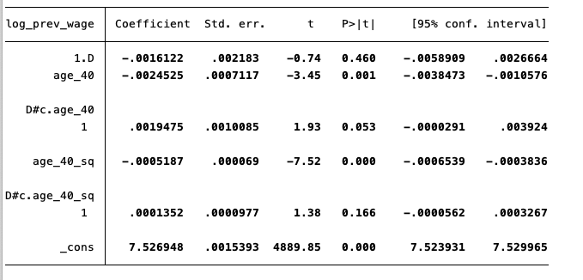
Rou_hat = -0.0016, which means that for those whose age is around 40, the reformation decreased the monthly wages by 1.61% on average.
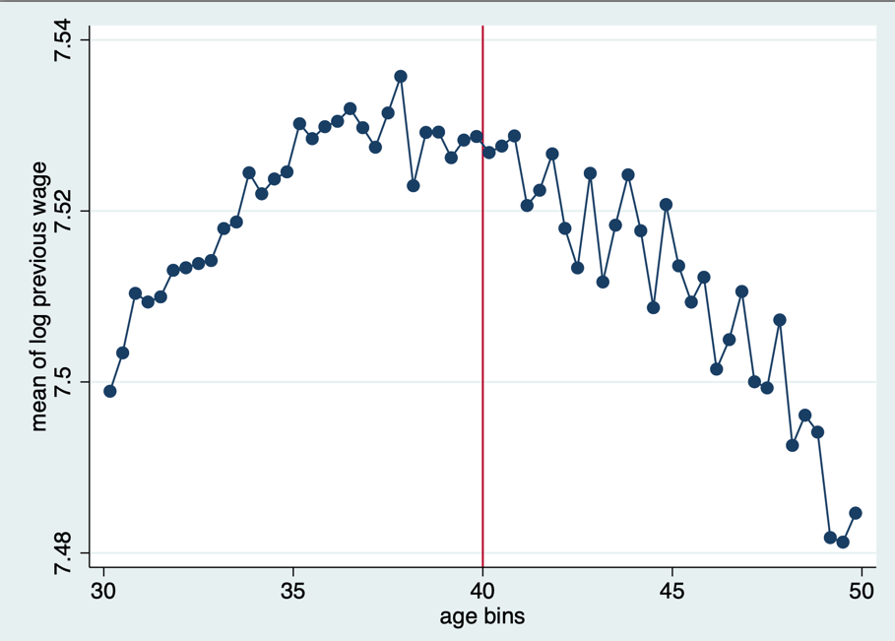
The previous wage evolves smoothly through the age 40 threshold.

2c
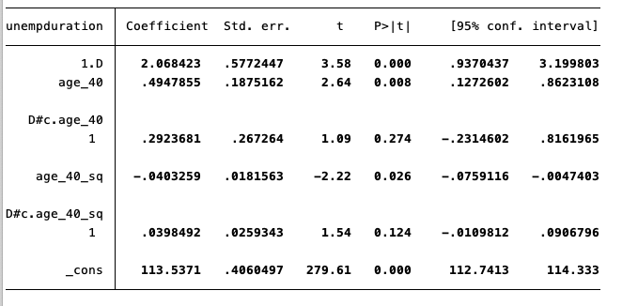
Rou_hat = 2.068, which means that for those whose age is around 40, the reformation increased the unemployment duration by 2days on average.
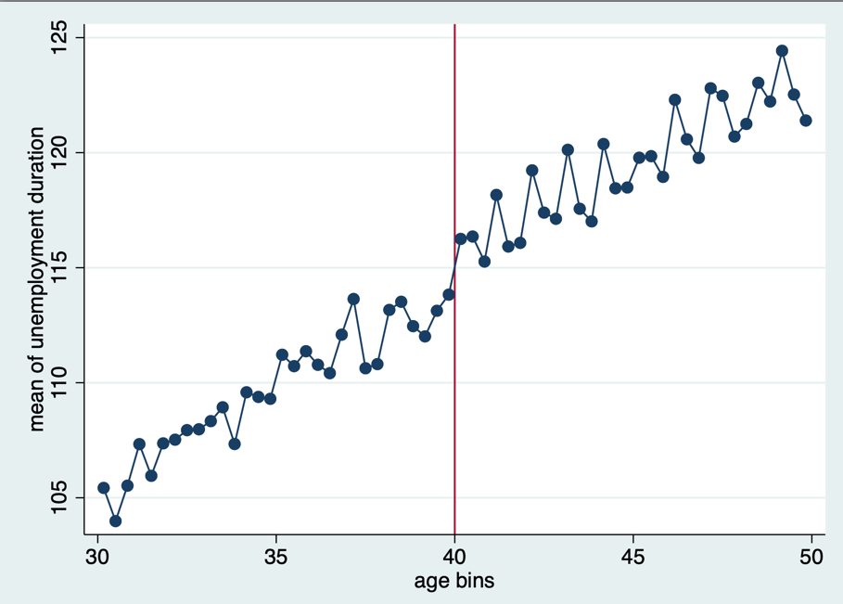

2d
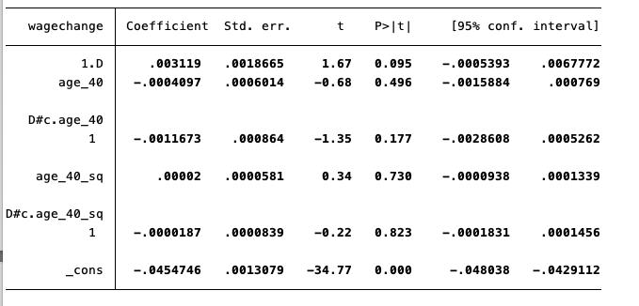
Rou_hat = 0.0031, which means that for those whose age is around 40, the reformation increased the change in log wage between post- and pre- unemployment jobs by 0.31% on average.
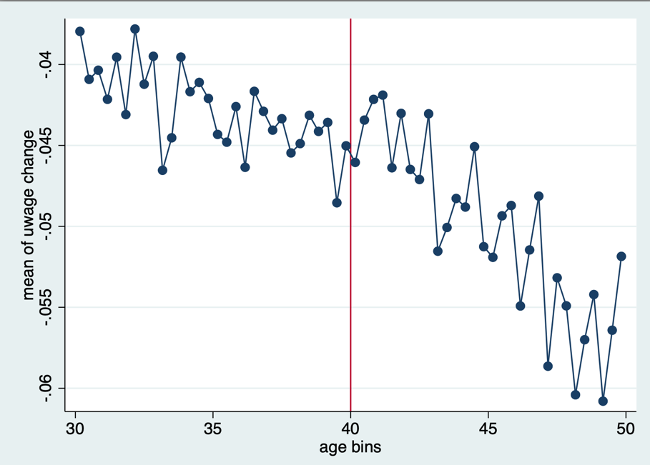

2e
Take marital status as an example:
Being married means family can give support during unemployment. Therefore can have a positive effect on unemployment duration. Since marital status is positively related to whether above age 40, including marital status can decrease estimated rou for unemployment duration.

2f
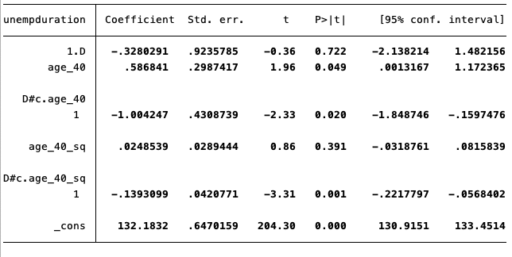
Rou_hat=-0.328, but very insignificant, which means at around 40, people who are a little above 40 have similar unemployment duration compared to who are a little below 40.

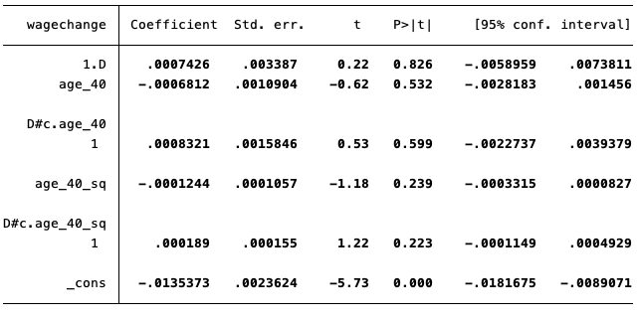
Rou_hat=0.000, but very insignificant, which means at around 40, people who are a little above 40 have similar wage change before and after unemployment compared to who are a little below 40.

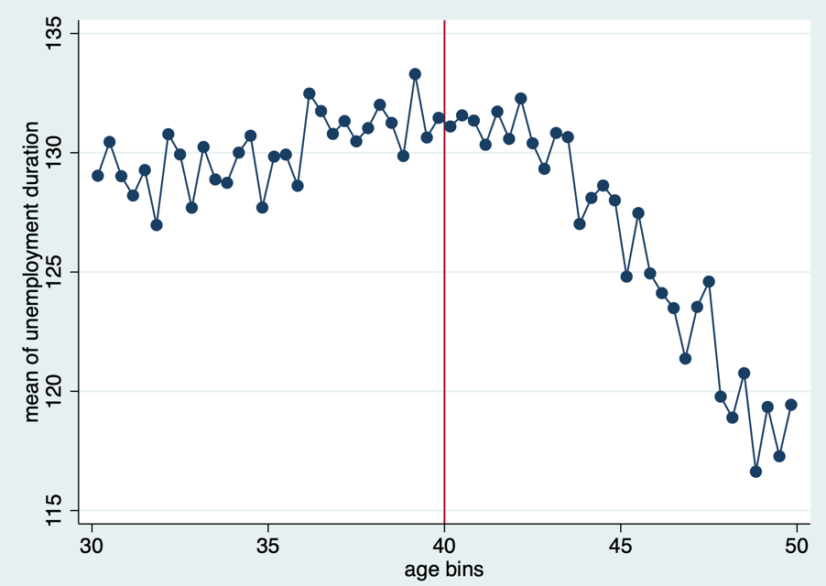
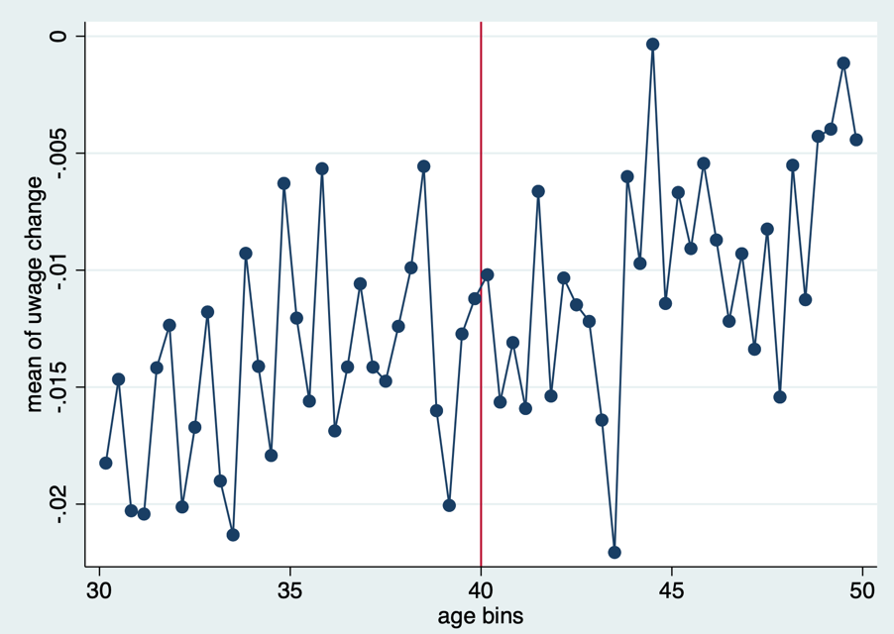

The results show that the identification assumption holds, there was no discontinuity in nonemployment duration or wage growth at the cutoff before the rule was implemented.

