Using Theorem 6.4.1 on page, we need to find out the $r_{k}$’s for $k=1,…,7$
Notice that $r_{k}$ is defined to be
Obviously $r_{1}=13$since there are 13 forbidden places in total.
In order to get $r_{k}$ for $k≥2$, we notice that since those forbidden slots join to form a single stripe, we may think of $r_{k}$ as the number of ways of placing $k$objects in a row of $13$ empty spaces without any two of them next to each other.
The number of selecting $k$ objects from $n$ objections in a row such that no two consecutive objects are chosen is given by
$$\left(\begin{matrix}n-k+1 \\ k\end{matrix}\right)$$
We illustrate how we obtain the formula above using $k=4, n=10$. Suppose we already have the following configuration
$$*\left|* \right|*|*$$
where the 4 * are the four objects we have chosen, and the three bars are three objects that we don’t choose (we must have those three bars there to make sure the four * are separated). Now we have used $k+k-1=4+3=7$ objects, and we are free to insert the other $n-\left(k+k-1\right)=3$ bars anywhere in the configuration (in the 5 regions separated by *). It is equivalent to decomposing $3$ into the sum of $k+1=5$ non-negative integers. Each integer corresponds to how many bars we place in each region. For instance, if $3=1+0+2+0+0$, we place 1 bar in the first region, 0 in the second, 2 in the third and 0 in the last, we have
$$|*|*|||*|*$$
where red bars are those we newly add.
And the total number of ways of decomposing $n-\left(k+k-1\right)$ into $k+1$ non-negative integers is given by
$$\left(\begin{matrix}n-\left(2k-1\right)+\left(k+1\right)-1 \\ (k+1)-1\end{matrix}\right)=\left(\begin{matrix}n-k+1 \\ k\end{matrix}\right)$$
We have talked about this before. Do you remember? I hope you do. If not, see the screenshot below and remember to review things regularly.
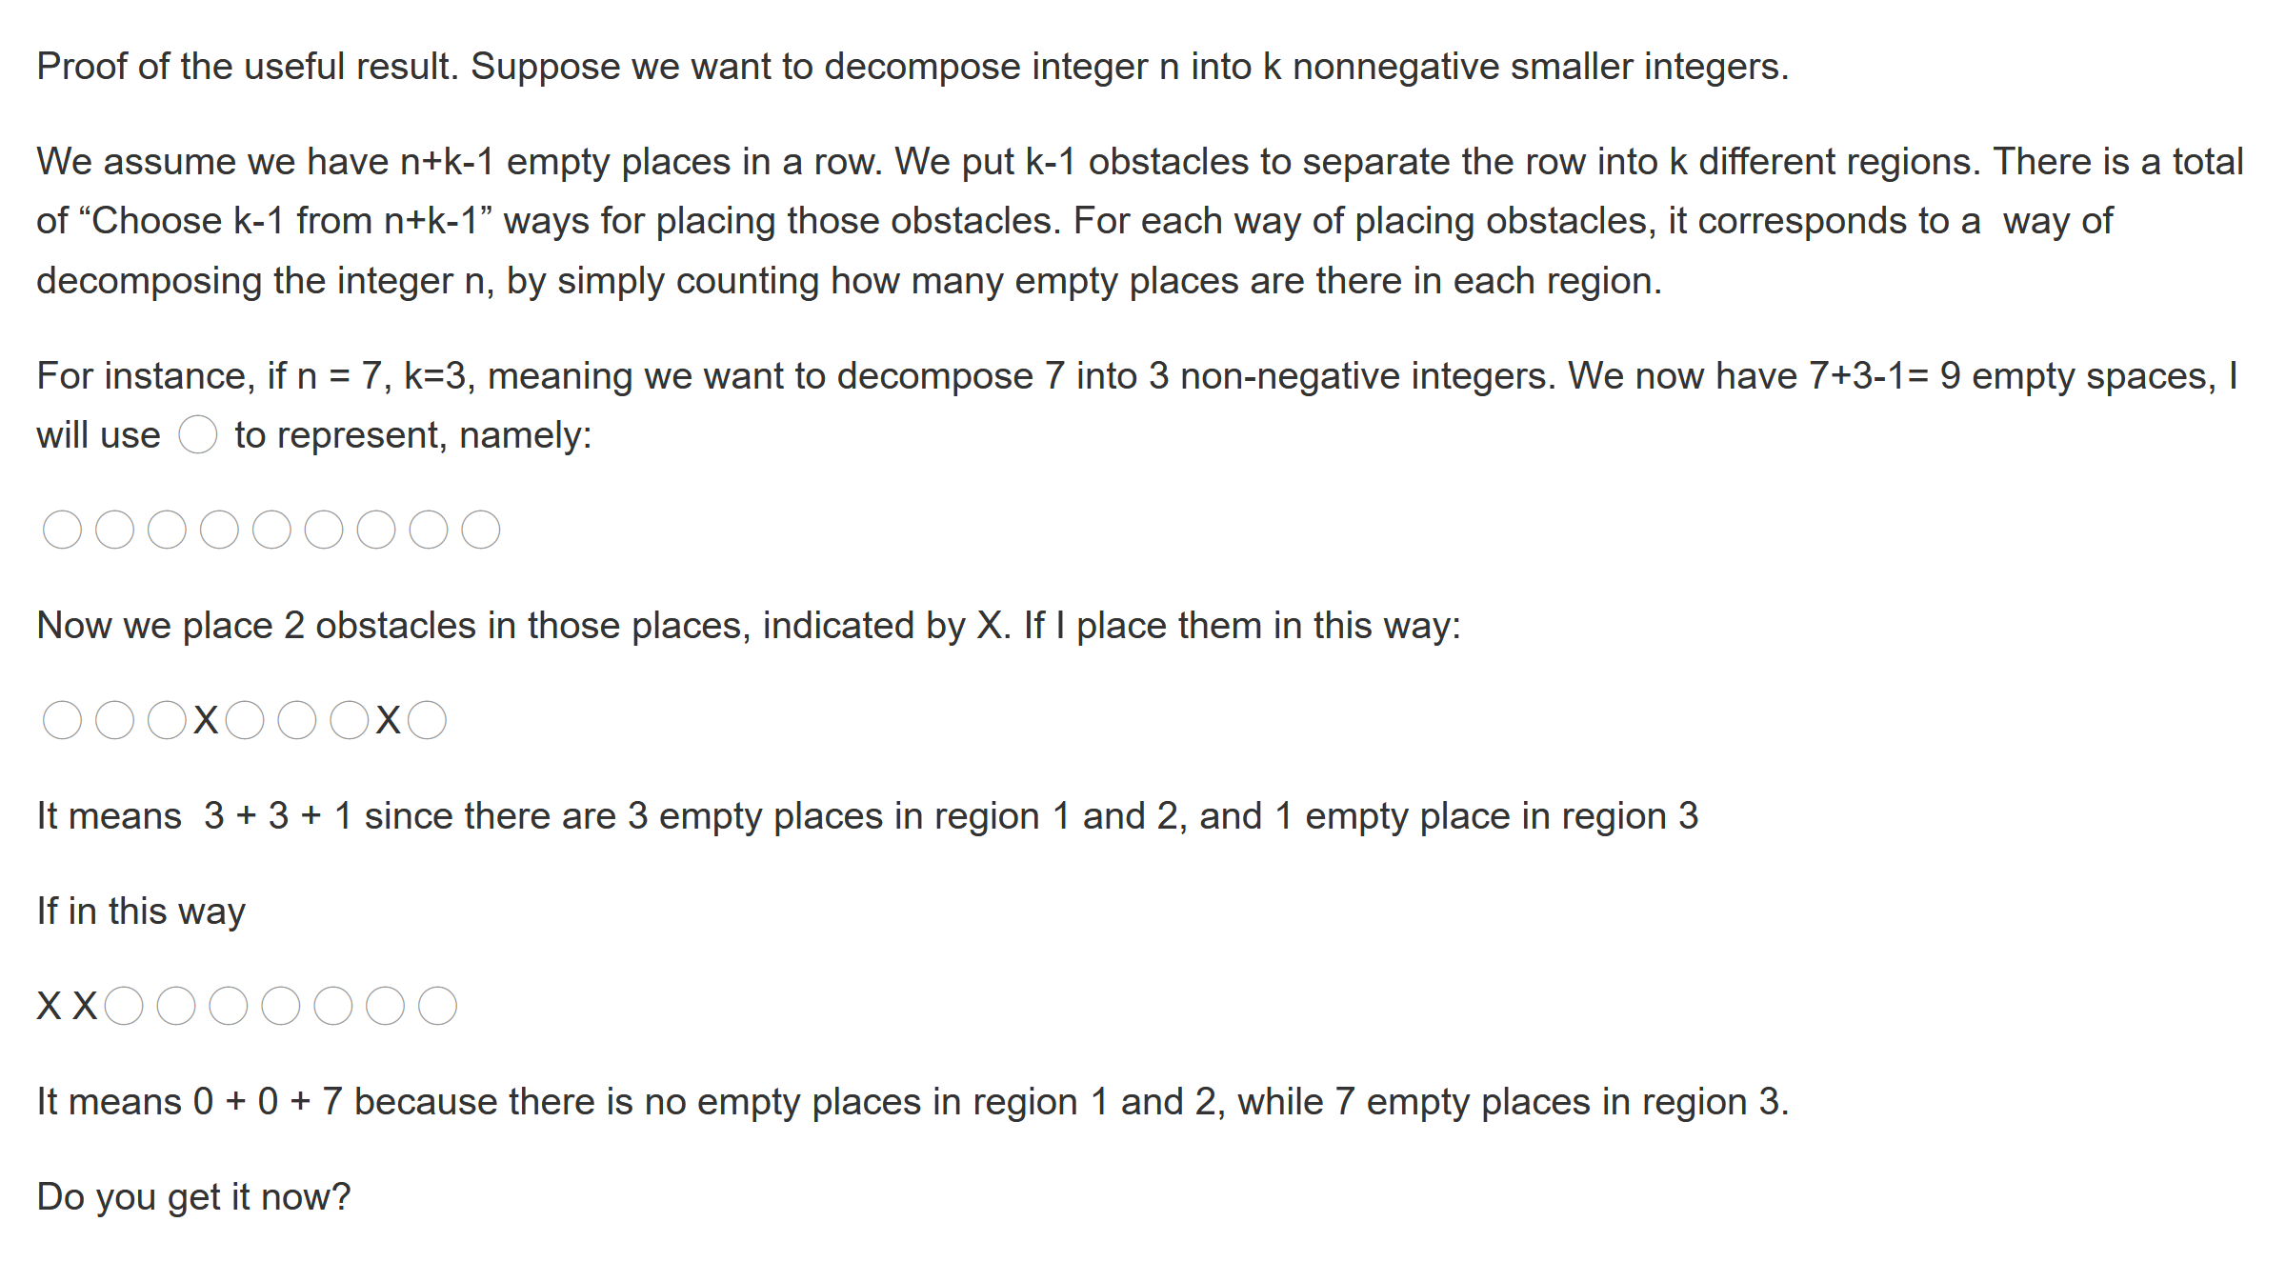
Thus, we have
$$r_{2}=\left(\begin{matrix}13-2+1 \\ 2\end{matrix}\right)=\left(\begin{matrix}12 \\ 2\end{matrix}\right)=66$$
$$r_{3}=\left(\begin{matrix}11 \\ 3\end{matrix}\right)=165$$
$$r_{4}=\left(\begin{matrix}10 \\ 4\end{matrix}\right)=210$$
$$r_{5}=\left(\begin{matrix}9 \\ 5\end{matrix}\right)=126$$
$$r_{6}=\left(\begin{matrix}8 \\ 6\end{matrix}\right)=28$$
$$r_{7}=\left(\begin{matrix}7 \\ 7\end{matrix}\right)=1$$
Put in theorem 6.3.1 to get
$$7!-13×6!+66×5!-165×4!+210×3!-126×2!+28×1!-1=675$$

This method is much better than the one I had previously.

