We prove that every continuous function that vanishes at infinity can be approximated by a sequence of functions with compact support in the uniform norm.

Take $f∈C_{0}(R^{n})$, by definition of vanishing at infinity, for any $ϵ$, we can always find a $K$ such that when $\left|x\right|≥K$, we have $\left|f\left(x\right)\right|<ϵ$. Now we construct another continuous function $ϕ_{K}(x)$ that is constant $1$ inside the ball $\left|x\right|≤K$, and vanishes outside the ball $\left|x\right|≥K+1$, while in the region in between, it is between 0 and 1. In order to do this, we simply take $ϕ_{K}(x)$ to be constant 1 inside the ball $\left|x\right|≤K$, and outside we take $ϕ_{K}(x)$ to be the distance between $x$ and the region $\left|x\right|≥K+1$ (the distance is 0 if $x$ is inside the region).
In 1-d, the function looks like this.
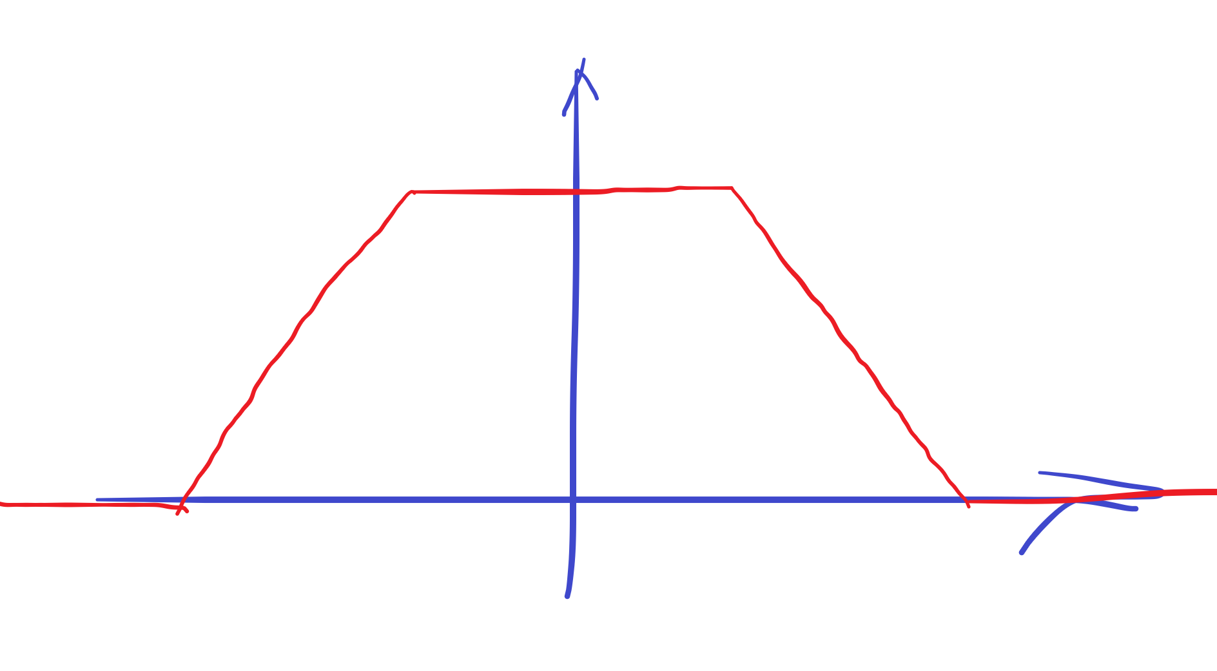
(Actually, we can even make this function infinitely differentiable by smoothing the edges. It’s called a plateau function in general, a typical plot of which is shown below. But for your question, we don’t consider differentiability. Just to let you know that it is possible).
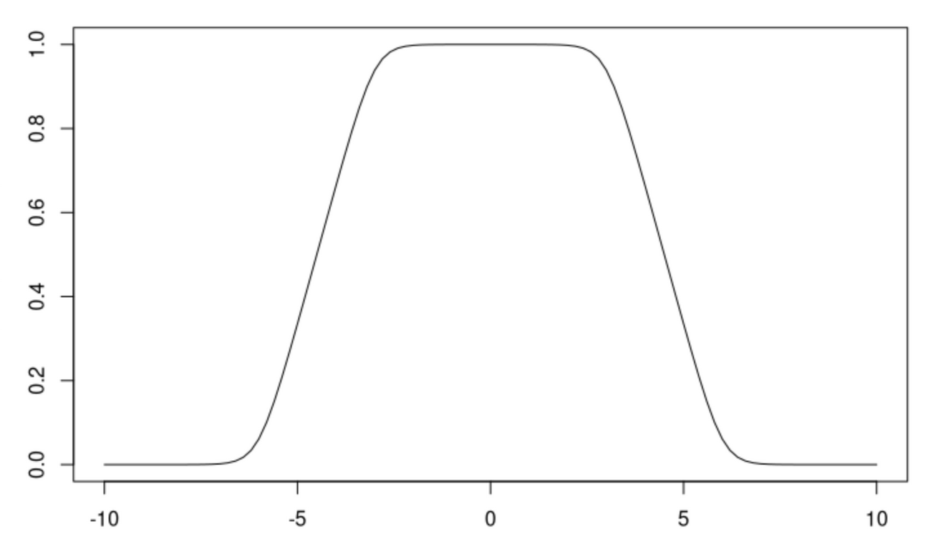
After we have $ϕ_{K}(x)$, we consider $f_{K}\left(x\right)=f\left(x\right)ϕ_{K}(x)$. This is a continuous function (since it is the product of two continuous functions), has compact support (since $ϕ_{K}$ is compactly supported in $\left|x\right|≤K$) and so $f_{K}∈C_{C}(R^{n})$.
Now we proceed to construct the sequence in the following way: take $ϵ=1/n$, we have a corresponding $K_{n}$ for $ϵ=1/n$. We construct a $ϕ_{K_{n}}$ and define $f_{n}\left(x\right)=f\left(x\right)ϕ_{K_{n}}\left(x\right).$ By construction we have every $f_{n}(x)$ compactly supported, so $f_{n}∈C_{C}(R^{n})$. On the other hand, we have
$$\sup_{x∈R^{n}}{|f\left(x\right)-f_{n}(x)|}<ϵ=\frac{1}{n}$$
since inside the ball $\left|x\right|≤K_{n}$, $f\left(x\right)-f_{n}(x)$ is always zero (since $ϕ_{K_{n}}$=1 inside), and outside the ball, we have
$$\left|f\left(x\right)-f_{n}\left(x\right)\right|=\left|f\left(x\right)-f\left(x\right)ϕ_{K_{n}}\left(x\right)\right|≤\left|f\left(x\right)\right|\left|1-ϕ_{K_{n}}\left(x\right)\right|≤\left|f\left(x\right)\right|≤ϵ$$
since $\left|f\left(x\right)\right|≤ϵ$ is always true in the region $\left|x\right|≥K_{n}$, and $\left|1-ϕ_{K_{n}}\left(x\right)\right|≤1$ is always true.
Thus, $f_{n}(x)$ is the sequence we want, meaning that the closure of compactly supported continuous functions is continuous functions that vanish at infinity.

