- We have
$$U=ZX+(1-Z)R$$
$$V=ZY+\left(1-Z\right)\sqrt{1-R^{2}}$$
We dissect the $\{U=u\}$ condition into two non-intersecting parts
$$\left\{U=u\right\}=\left\{U=u | Z=0\right\}∪\{U=u|Z=1\}$$
Since $P\left(Z=0\right)=P\left(Z=1\right)=0.5$, we have
$$E\left(V|U=u\right)=\frac{1}{2}E\left(V|U=u,Z=0\right)+\frac{1}{2}E\left(V|U=u,Z=1\right)$$
Notice that in the case $Z=0$, we have $U=R$ and $V=\sqrt{1-R^{2}}$
$$E\left(V|U=u,Z=0\right)=E\left(\sqrt{1-R^{2}}| U=R=u\right)=\sqrt{1-u^{2}}$$
for $u∈[-1, 1]$, and for $u$ outside the region it is simply zero since the condition $\left|u\right|>1$ is not compatible with the distribution.
In the case $Z=1$, we have $U=X$, and $V=Y$. Since $\left(X,Y\right)$ are uniformly distributed on the unit disk $B(0,1)$. Conditioned on the fact that $U=X=u$, the expectation of $V=Y$ is simply zero due to symmetry that $(X,±Y)$ follows the same distribution. Thus
$$E\left(V|U=u,Z=1\right)=E\left(Y| U=X=u\right)$$
$$=\frac{1}{2}\left(E\left(Y| X=u\right)+E\left(-Y| X=u\right)\right)$$
$$=\frac{1}{2}E\left(Y-Y| X=u\right)=0$$
where we have used the symmetry mentioned above to split $E\left(Y| X=u\right)$ into two parts, whose sum is 0. (This trick is also used in the previous Exercise 1. See the picture at the end)
Thus, we have
$$E\left(V|U=u\right)=\frac{1}{2}\sqrt{1-u^{2}}$$
- We still split the $\left\{U=u\right\}$ into two non-intersecting part
$$\left\{U=u\right\}=\left\{U=u | Z=0\right\}∪\{U=u|Z=1\}$$
In the case $Z=0$, we again have $U=R$ and $V=\sqrt{1-R^{2}}$, and
$$P(V≤q_{3/4}(u)|U=u,Z=0)=P(\sqrt{1-R^{2}}≤q_{3/4}(u)|U=R=u)$$
$$=P(\sqrt{1-u^{2}}≤q_{3/4}(u))$$
We notice that $\sqrt{1-u^{2}}$ is a fixed value (not a random variable anymore) under the condition $U=u, Z=0$. Thus, the probability is either 1 or 0 depending on whether $\sqrt{1-u^{2}}≤q_{3/4}(u)$ is true.
In the case $Z=1$, we have $U=X$, and $V=Y$, and it becomes a situation which we have handled in Exercise 1 (see below). The answer is that
$$q_{3/4}(u)=\frac{1}{2}\sqrt{1-u^{2}}$$
is the function that will make
$$P\left(V=Y≤q_{3/4} \left(u\right) | X=U=u\right)=\frac{3}{4}$$
hold. Now we combine both cases, each one contributing one half to the final probability because $Z$ has equal probability of being 0 or 1. If we have $q_{3/4} \left(u\right)≥\sqrt{1-u^{2}}$, we will always have
$$P(V≤q_{3/4}(u)|U=u,Z=0)=P(\sqrt{1-u^{2}}≤q_{3/4}(u)) =1$$
and so, it will contribute 1/2 to our final result, but if $q_{3/4} \left(u\right)≥\sqrt{1-u^{2}}$ is true, the second part $P\left(Y≤q_{3/4} \left(u\right) | X=u\right)$ will also be 1 (since when $X=u$ is set, $Y≤\sqrt{1-u^{2}}$ must happen), therefore contributing another 1/2. The final result will just be 1.

On the other hand, if $q_{3/4} \left(u\right)<\sqrt{1-u^{2}}$, we will have
$$P(\sqrt{1-u^{2}}≤q_{3/4}(u)) =0$$
Thus the first part contribute nothing, which means that if we want the final probability to be $3/4$, we need the second part to be $3/2$ (and taken half, it will be the 3/4 we want), which is impossible because the second probability can at most be 1.

Thus, there is no $q_{3/4}(u)$ that can fulfill this property. We may take the case $u=0$ as a more detailed illustration. In the case $U=u=0$, we have either $Z=0,R=0$ or $Z=1, X=0$, in the first case, $V=\sqrt{1-R^{2}}=1$ is a fixed point. In the second case, $V=Y$ is uniformly distributed along the line connecting $(0,-1)$ and $(0, 1)$ (we denote it by set A). Thus, the probability density of $V$ is given by
$$f\left(v\right)=\frac{1}{2}δ\left(v-1\right)+\frac{1}{2}1_{A}(v)$$
where $δ(v-1)$ is a Dirac delta function concentrated at $y=1$ and $1_{A}(v)$ indicates the uniform distribution on the vertical line segment $A$. You can never find a point where the cumulative probability $F\left(v\right)=3/4$ because $F\left(v\right)$ starts at 0, and linearly grows to $1/2$ when $v$ goes from -1 and 1, and suddenly jumps to 1 when $v$ reaches the point 1, as indicated by the diagram below.
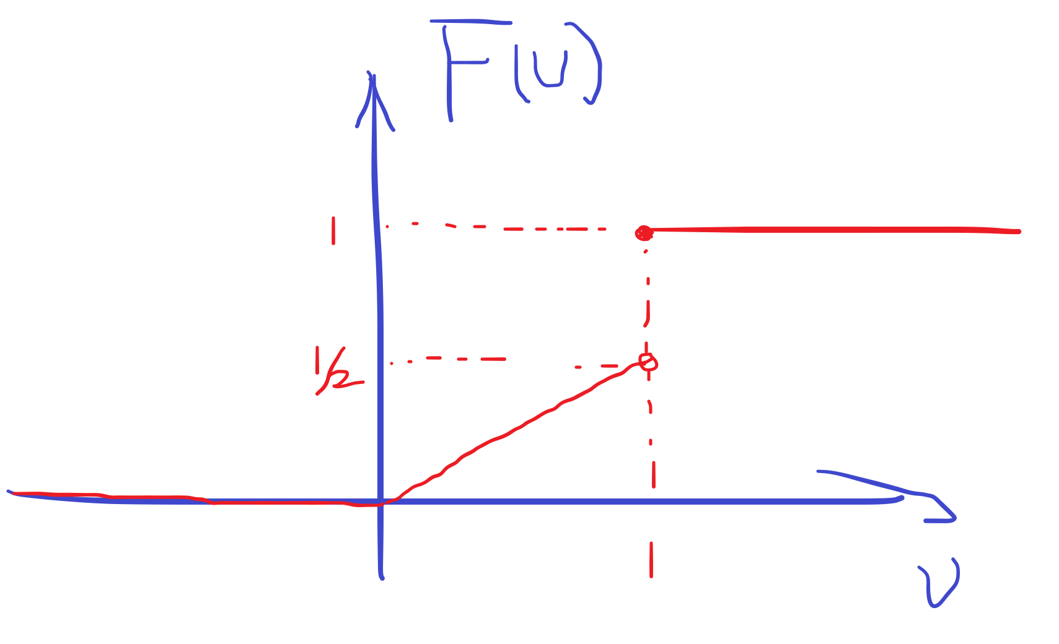
There is simply no choice of value of $q_{3/4}(u)$ at $u=0$ such that can make
$$P(V≤q_{3/4}(0)|U=0)=3/4$$
Thus, the answer is that $q_{3/4}(u)$ doesn’t exist.
Finally, U and V cannot be independent, as they are not in either $Z=0$ or $Z=1$.
(We have proved rigorously why they are not independent for $Z=1$ case, see Exercise 2 below)
