- (a) Suppose the electric field is not spherical symmetric, then it will have a component that is not parallel with the radius. In the plot below, we indicate the electric field by a solid blue arrow at that place. Then, if we flip the system around the horizontal dashed line, we get the same system as before, but now the solid blue arrow get flipped to the dashed blue arrow, which is inconsistent because we cannot have two different fields for the same system. Thus, the electric field must be pointing in the radius direction.
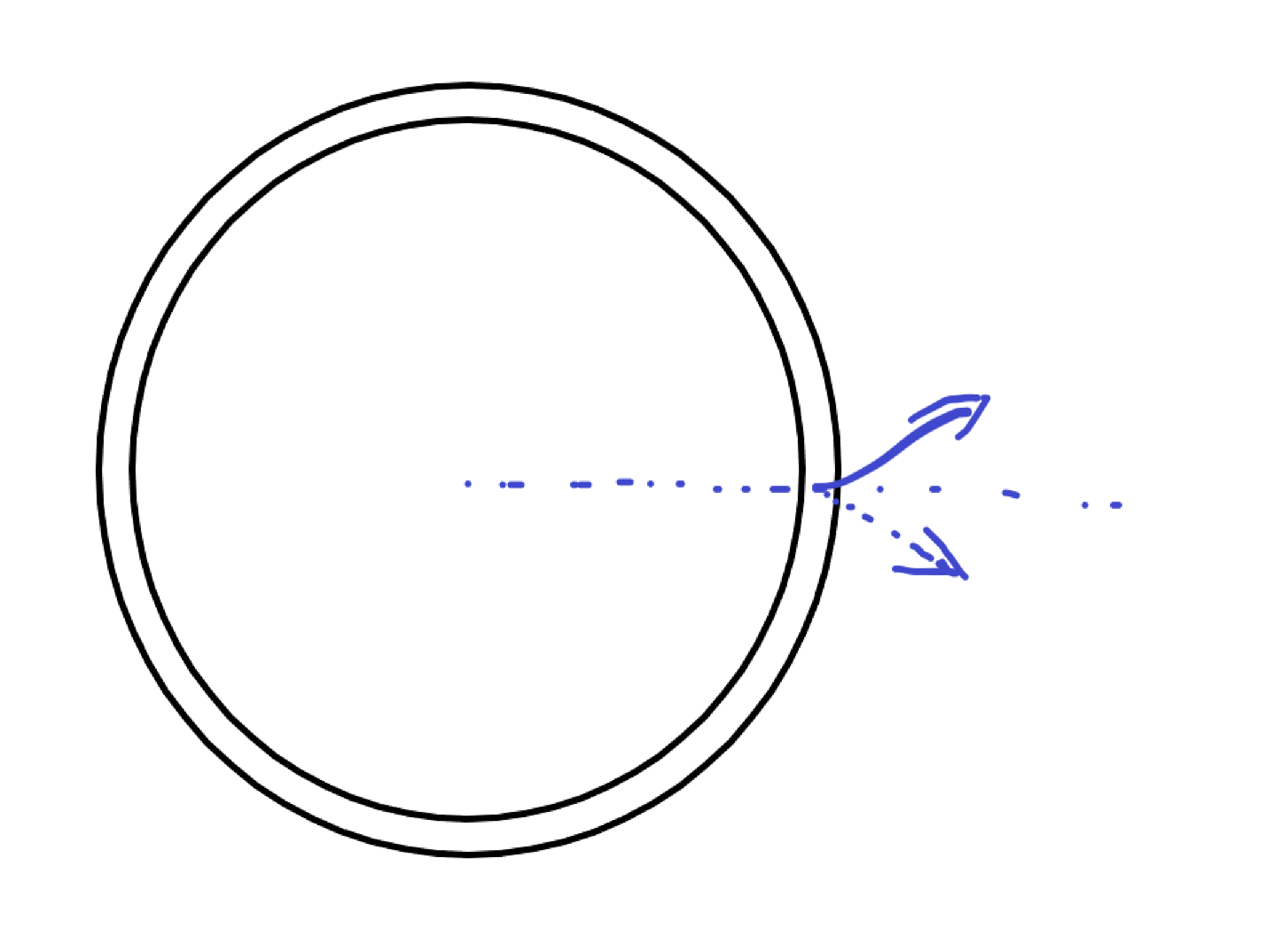
Now we know that the electric field aways point away from the center. Next we show their magnitude is the same everywhere. Using rotational symmetry, we see that if we rotate the system such that the blue arrow is moved parallel to the red one, we still have the same system, and thus the magnitudes of the two vectors are the same.
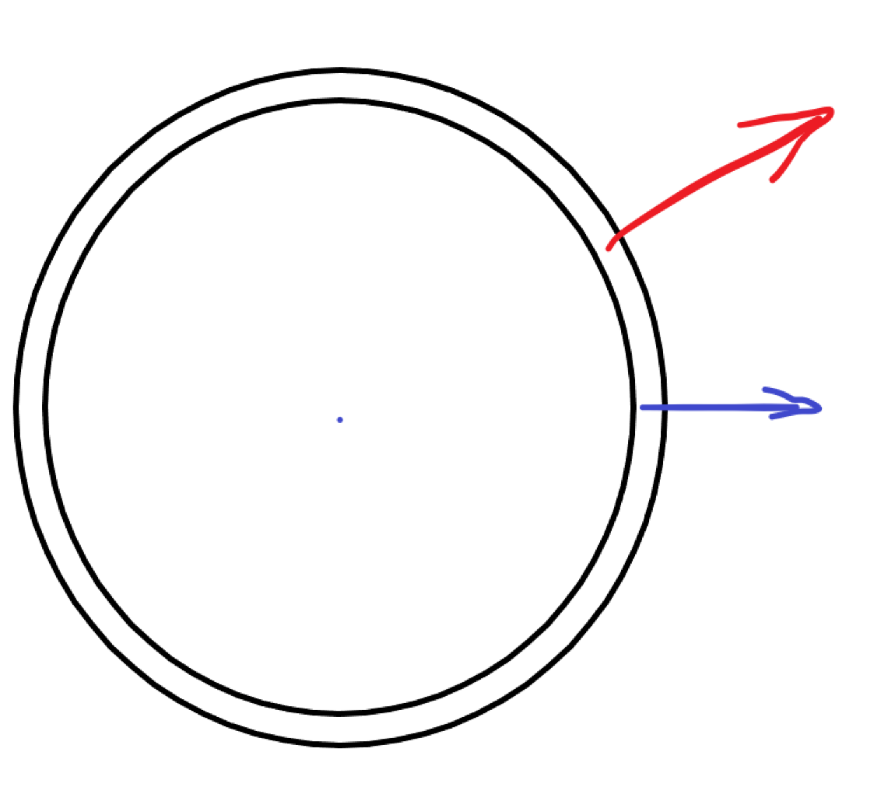
Since we can relate any two points by rotation, we know that the electric field has the same magnitude everywhere. Thus, the electric field is spherical symmetric.
(b) The electric field in the cell membrane is given by
$$4πs^{2}E(s)=Φ_{E}=\frac{-Q}{Kϵ_{0}}$$
which gives
$$E\left(s\right)=\frac{-Q}{4πKϵ_{0}s^{2}} \hat{s}$$
where $s∈(r-a,a)$ is inside the membrane, and the direction is obviously inwards.
(c) The potential difference is given by
$$V=-\int_{r-a}^{r}{E\left(s\right)⋅\hat{s}ds}=\frac{Q}{4πKϵ_{0}}\left(\frac{1}{r-a}-\frac{1}{r}\right)=\frac{aQ}{4πKϵ_{0}r(r-a)}$$
The result is positive, indicating that the exterior side has higher potential.
(d) The capacitance is given by
$$C=\frac{Q}{V}=4πKϵ_{0}r\left(\frac{r}{a}-1\right)$$
- (a) We put numeric values in the result above to get
$$C=2.436×{10}^{-10}(F)$$
(b) The capacitance of a parallel plate with plate separation $a$ and area $A=4πr^{2}$ is given by
$$\frac{Kϵ_{0}A}{a}=2.447×{10}^{-10}(F)$$
They are similar because the value of $a$ is extremely small, that locally we may treat spherical surfaces as plain surfaces. (Image what happens the two curves below getting extremely close)
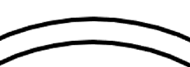
(c) We have
$$Q=CV=2.43×{10}^{-5}(C)$$
Notice that we have change the sign of $V$ because we want Q to be a positive number.
(d) If the amount of induced charge (on the interior surface) is $Q'$, we have
$$\frac{Q}{4πKϵ_{0}s^{2}}=\frac{Q-Q'}{4πϵ_{0}s^{2}}$$
which shows that
$$Q^{'}=\frac{K-1}{K}Q$$
Thus, on the surface, the total amount of free change is
$$Q-Q^{'}=\frac{1}{K}Q$$
and the surface density is
$$\frac{Q}{4Kπr^{2}}=-0.176 (C m^{-2})$$
(e) The charge density (I will assume it means surface density) inside the membrane is
$$\frac{Q^{'}}{4πr^{2}}=\frac{K-1}{4Kπr^{2}}Q=1.762(C m^{-2})$$
(f) Below is the diagram, the blue charges are negative charges inside the cell, red charges are bound charges in the membrane, and the red ones are free charges indued outside the cell. The polarization goes from negative red charges to positive red charges (indicated by red arrows).
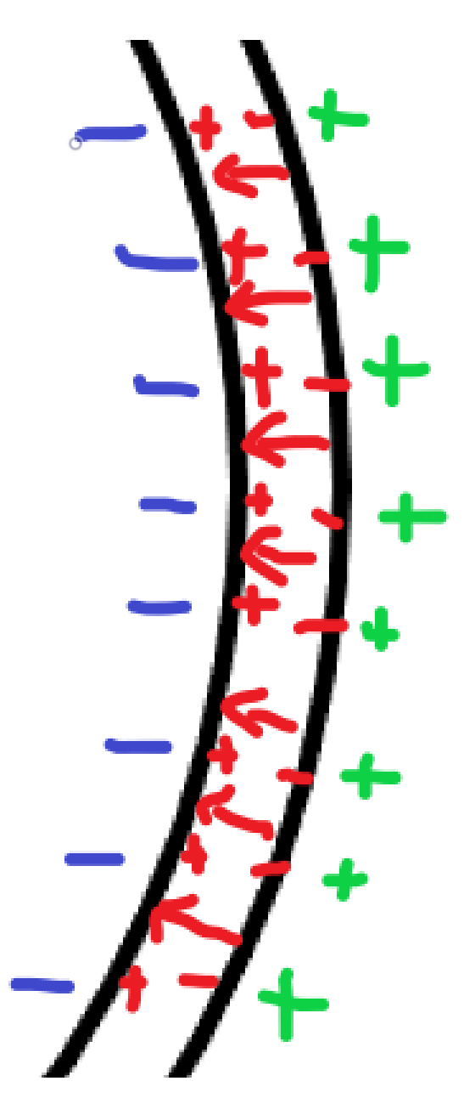
- (a) The current density due to diffusion is
$$J_{r,diff}=-\frac{σk_{B}T}{qN}\frac{dN}{dr}$$
If we want an equilibrium, we have
$$J_{r,diff}=-σE$$
which gives
$$-σE=-\frac{σk_{B}T}{qN}\frac{dN}{dr}$$
and thus
$$E=\frac{k_{B}T}{q}\frac{d(\ln{N})}{dr}$$
where we have used the chain rule $d\left(\ln{N}\right)=dN/N$
We have thus
$$dV=-Edr=-\frac{k_{B}T}{q} d(\ln{N})$$
(b)
Integrate to get
$$V=-\int_{r_{in}}^{r_{out}}{Edr}=-\int_{r_{in}}^{r_{out}}{\frac{k_{B}T}{q} d\left(\ln{N}\right)}= -\frac{k_{B}T}{q}\left(\ln{N_{out}}-\ln{N_{in}}\right)=\frac{k_{B}T}{q}\ln{(N_{in}/N_{out})}$$
(c) Plug in numeric values $k_{B}=1.38×{10}^{-23} (J/K)$ , $q=1.6×{10}^{-19}\left(C\right)$ to get
$$V=\frac{k_{B}T}{q}\ln{(N_{in}/N_{out})}=0.085(V)$$
Which is around 85 mV, relatively closed to what we have in the previous question where V=110 mV
- You may need to confirm with your instructor about the numeric values in this problem. For instance, what is the strength of magnetic field at Sydney harbor. It is not given in the problem.
(a) I am not sure what it means by “oriented vertically”, does it mean the rod is perpendicular to the magnetic field? How is the velocity oriented? I will calculate with the assumption that the velocity, the rod, and the magnetic field are mutually perpendicular.
The potential difference is given by Farady’s law of induction that
$$V=Blv$$
(b) Below is a diagram. The circuits contain the ampullary organ that moves in magnetic field to produce Emf, the resistor at the end of the organ, and another resistor due to the environment and the rest of the body.
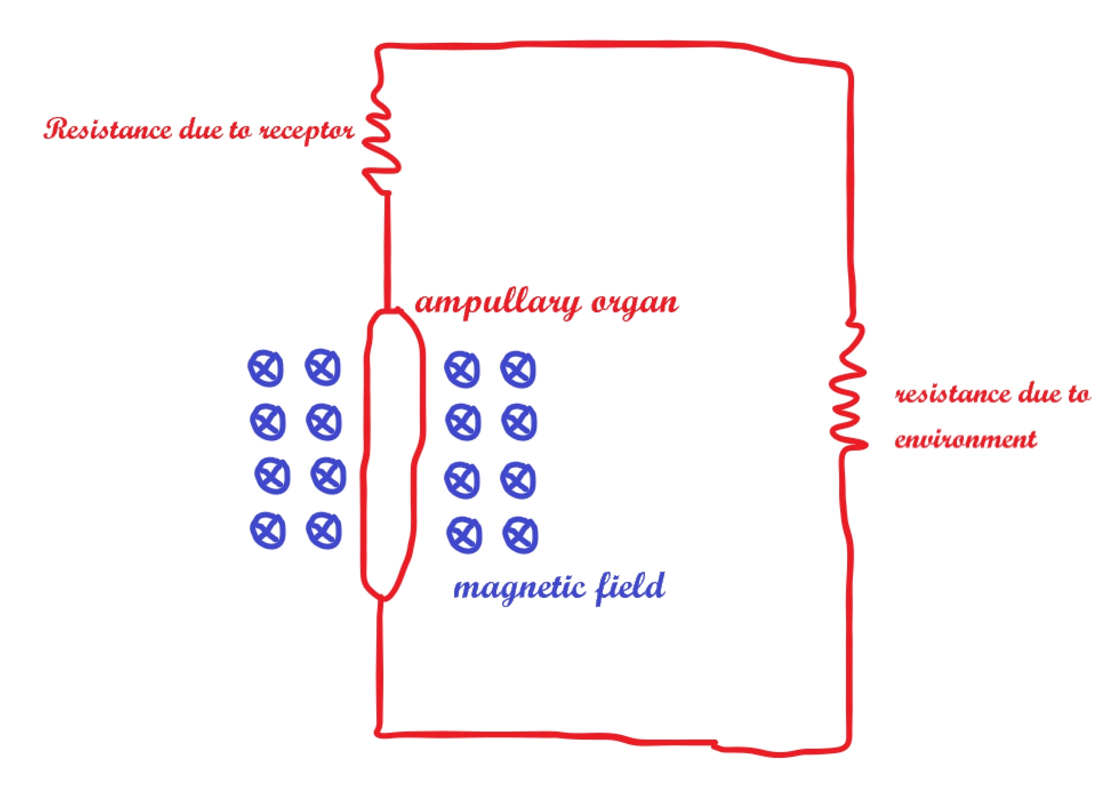
(c) The voltage across the receptor is, by Ohm’s law
$$\frac{V}{R}R_{r}=\frac{BlvR_{r}}{R}$$
(d) According to this site
https://www.magnetic-declination.com/Australia/Sydney/124736.html
The magnetic field at Sydney is 0.057 mT. The EMF per centimeter is given by
$$Bv=2.85×{10}^{-5} (V/cm)$$
If we also consider the 65 degrees inclination of the B field above horizontal, the result will be multiplied by another factor of $cos\left(65°\right)\sim 0.4226$
(e) It is slightly higher than the range that a shark can detect. (But, as we have mentioned above, due to the possible inclination of B field, as well as the particular direction of the shark’s velocity, it could be in the range)
(f) Since $l=10$ cm, The range of detectable voltage for the ampullary organ is given by between
$$5 (nV/cm) ×10(cm)=50(nV)$$
and
$$1(μV/cm) ×10(cm)=10(μV)$$
Since $R_{r}/R\sim 0.5,$ the acceptor will take half of the voltage, thus the range is 25(nV) to 5($μV$) which is significantly smaller than the typical voltage across a cell wall.
(g) It takes further clarification on this question. How is the direction of the rod, the velocity and the magnetic field of the earth related? My calculations will be assuming that the three are mutually perpendicular when t=0.
The effective velocity (the component of the velocity that is perpendicular to the magnetic field) that generates EMF is given by $v^{'}=v\cos{(α\sin{(ωt)})}$, Thus, the EMF as a function of time is
$$V\left(t\right)=Blv^{'}=Blv\cos{(α\sin{(ωt)})}\sim Blv\left(1-\frac{α^{2}\sin^{2}\left(ωt\right)}{2}\right)$$
where we have done an expansion since $α$ is small.
(h) When it is moving in the east and west, the EMF is what we have in (g), because we are assuming the velocity to be perpendicular to the magnetic field in (g).
When it is going in the north and south direction. The effective velocity is now
$$v^{'}=v\sin{(α\sin{(ωt)})}$$
so we have
$$V\left(t\right)=Blv^{'}=Blv\sin{(α\sin{(ωt)})}\sim Blvα\sin{(ωt)}$$
which is significantly smaller than the previous result since $α$ is small.
(i) As we have mentioned in (h), moving in the east and west (perpendicular to the magnetic field) will have larger EMF. The shark can distinguish because moving in the north and south (or east and west) will produce different sign of $V$ with the same head direction. Thus, if it can tell the direction of its head and the sign of $V$, it will know the exact direction.
(j) Evolutionally speaking, terrestrial animals have more methods for determining direction and locations, while in oceans, animals don’t have many ways of navigating, and they tend to evolve organs that use electric/ magnetic fields to help navigation.

