- The velocity at B is given by
$$v_{B}=ω_{1}×\overline{AB}=\left(ω_{1}k\right)×(-l\cos\left(\frac{π}{3}\right)i+l\sin\left(\frac{π}{3}\right)j)$$
$$=-\sqrt{3}m s^{-1}i-1 m s^{-1}j$$
In order to find the angular velocity of rod (2), we need to answer the first part of question (b) first. Below is the diagram that indicates the zero-velocity point P. From it, we can see the relation between the angular velocity $ω_{2}$ of rod (2) and velocity $v_{B}$ of point B is given by
$$v_{B}=ω_{2}×\overline{PB}$$
which reads
$$-\sqrt{3}m s^{-1}i-1 m s^{-1}j=\left(ω_{2} k\right)×(1m i-\sqrt{3}m j)$$
and thus $ω_{2}=-1 rad m s^{-1}$, so $ω_{2}=-1 rad m s^{-1}k$
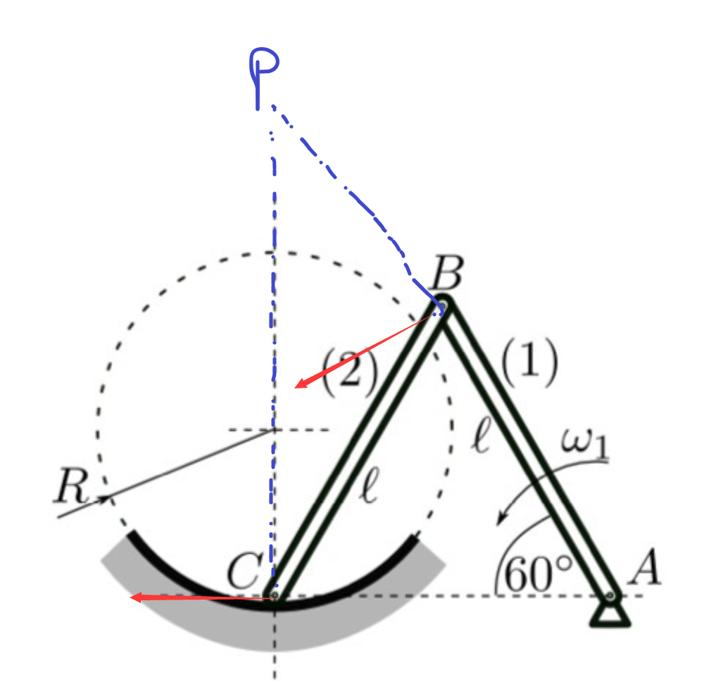
- The point P is shown above, the vector $r_{CP}$ is easily calculated to be
$$r_{CP}=2\sqrt{3} j$$
- The acceleration of point B is purely centripetal (since B is doing a constant angular motion), we have
$$a_{B}=ω_{1}^{2}l \hat{BA}$$
where we have used the centripetal acceleration formula, and $\hat{BA}$ is a unit vector pointing from B to A. Thus
$$a_{B}=1m s^{-2} i-\sqrt{3}m s^{-2} j$$
The acceleration of point C can be decomposed into two parts: the centripetal and tangential.
$$a_{C}=a_{C,⊥}+a_{C,∥}$$
The centripetal one is
$$a_{C,⊥}=ω_{2}^{2}\left|PC\right| j=2\sqrt{3} m s^{-2} j$$
The tangential acceleration is unknown, but we denote it by $a_{C,∥}=a_{C,∥}i$
We have the following relation between $a_{C}, a_{B}$
$$a_{C}=a_{B}+ϵ_{2}× \overline{BC}- ω_{2}^{2} \overline{BC}$$
which gives
$$a_{C,∥}i+2\sqrt{3} m s^{-2} j=1m s^{-2} i-\sqrt{3}m s^{-2} j+\left(ϵ_{2} k\right)×\left(-1m i-\sqrt{3}m j\right)-\left(-1m i-\sqrt{3}m j\right)$$
$$=\left(2m s^{-2}+\sqrt{3}ϵ_{2} m\right)i+(-ϵ_{2} m)j$$
Compare the two components to get
$$ϵ_{2}=-2\sqrt{3} rad s^{-2}$$
$$a_{C,∥}=-4 m s^{-2}$$
Thus $ϵ_{2}=ϵ_{2} k=-2\sqrt{3} rad s^{-2}k$
- If the speed of C is now $v_{C}=1 m s^{-1} i$, the zero-velocity point of rod (2) is the same P as shown in the diagram below.
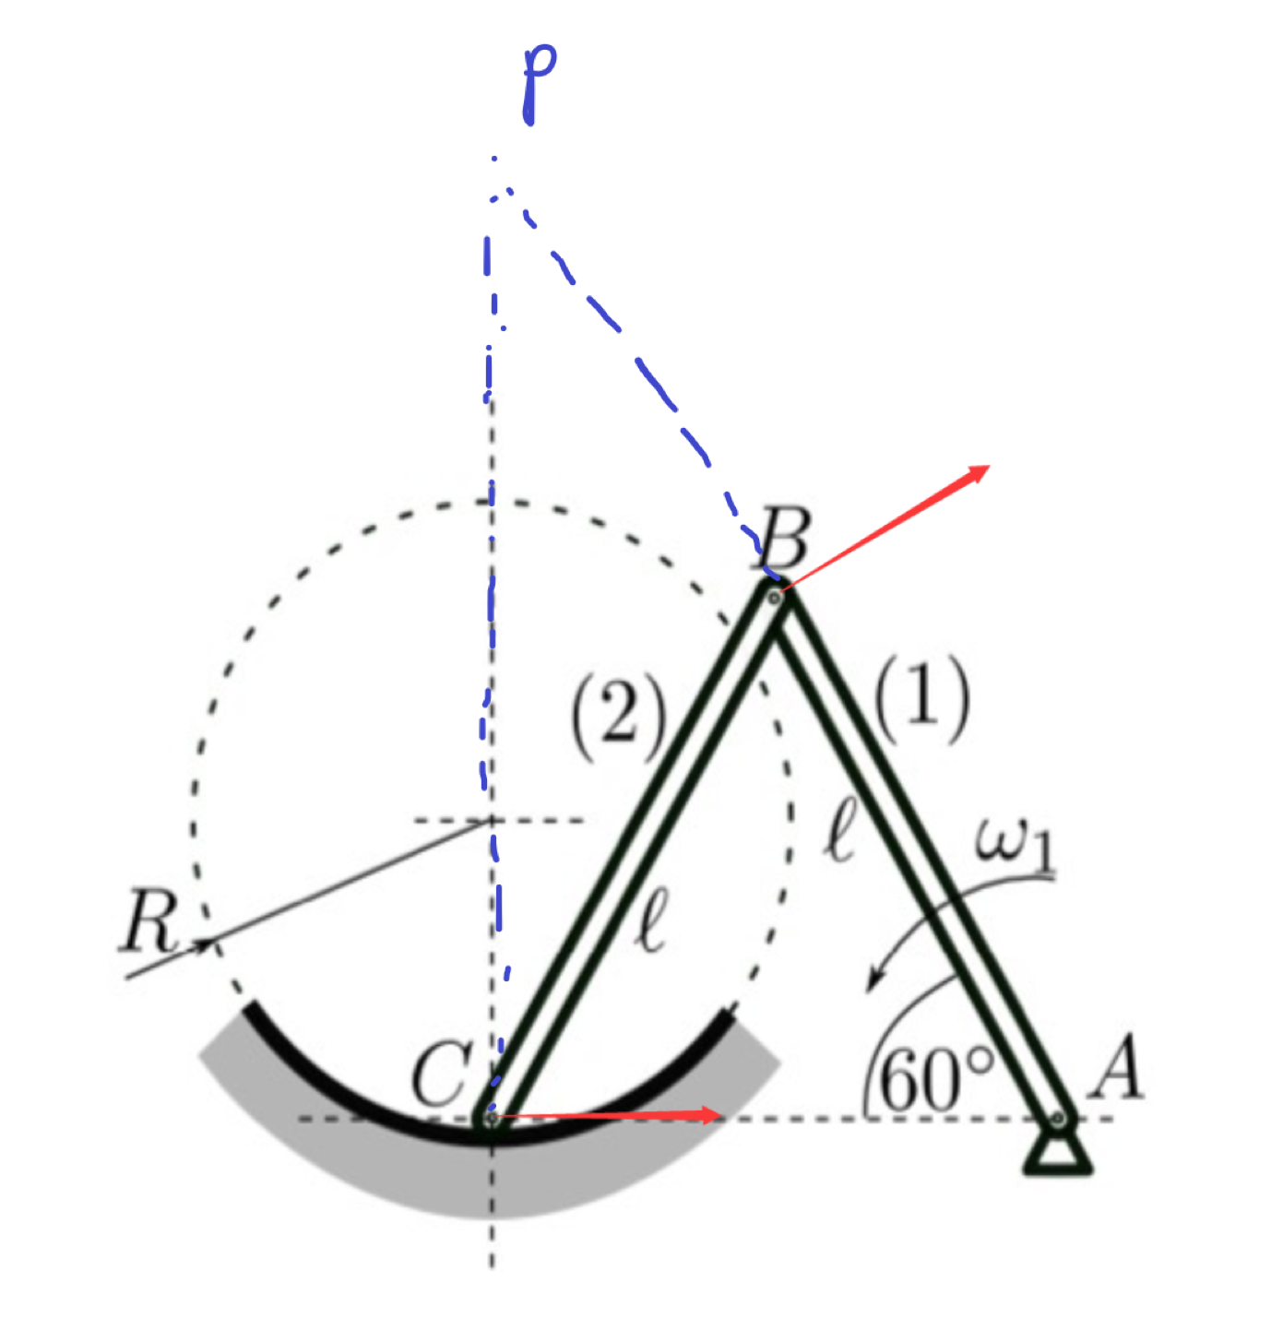
The angular velocity $ω_{2}$ of rod (2) is thus determined by
$$v_{C}=ω_{2}×\overline{PC}$$
which gives $ω_{2}=\sqrt{3}/6 rad s^{-1} k$. From this we can solve out the velocity of $B$ to be
$$v_{B}=ω_{2}×\overline{PB}=\frac{\sqrt{3}}{6}(\sqrt{3}i+j)$$
The angular velocity $ω_{1}$ of rod (1) is thus determined by
$$v_{B}=ω_{1}×\overline{AB}$$
which gives $ω_{1}=-\sqrt{3}/6 rad s^{-1} k$.
Since point C has a constant speed. It means that C is doing a uniform circular motion, and thus its acceleration is purely centripetal and given by
$$a_{C}=\frac{v_{c}^{2}}{R} j=1 m s^{-2} j$$
The accelerations of B and C are related by
$$a_{C}=a_{B}+ϵ_{2}× \overline{BC}- ω_{2}^{2} \overline{BC}$$
while the acceleration of B is given by
$$a_{B}=ϵ_{1}× \overline{AB}-ω_{1}^{2} \overline{AB}$$
Put it in to get
$$a_{C}=ϵ_{2}× \overline{BC}- ω_{2}^{2} \overline{BC}+ϵ_{1}× \overline{AB}-ω_{1}^{2} \overline{AB}$$
Put in numeric values that
$$a_{C}=1 m s^{-2} j$$
$$\overline{BC}=\left(-1m i-\sqrt{3}m j\right)$$
$$\overline{AB}=\left(-1m i+\sqrt{3}m j\right)$$
$$ω_{2}=-ω_{1}=\frac{\sqrt{3}}{6}rad s^{-1} k$$
to get
$$ϵ_{1}=\frac{-18+\sqrt{3}}{36} rad s^{-2} k, ϵ_{2}=\frac{-18-\sqrt{3}}{36}rad s^{-2} k$$
Put then into
$$a_{B}=ϵ_{1}× \overline{AB}-ω_{1}^{2} \overline{AB}$$
to get
$$a_{B}=\frac{\sqrt{3}}{2}m s^{-2}i+\left(\frac{1}{2}-\frac{\sqrt{3}}{9}\right)m s^{-2}j$$

