- Below is the sketch. The actual magnitude of the velocities $v_{A,B,C,D}$ may not be properly scaled. (They should be proportional to the length of $PA, PB, PC, PD$ segments)
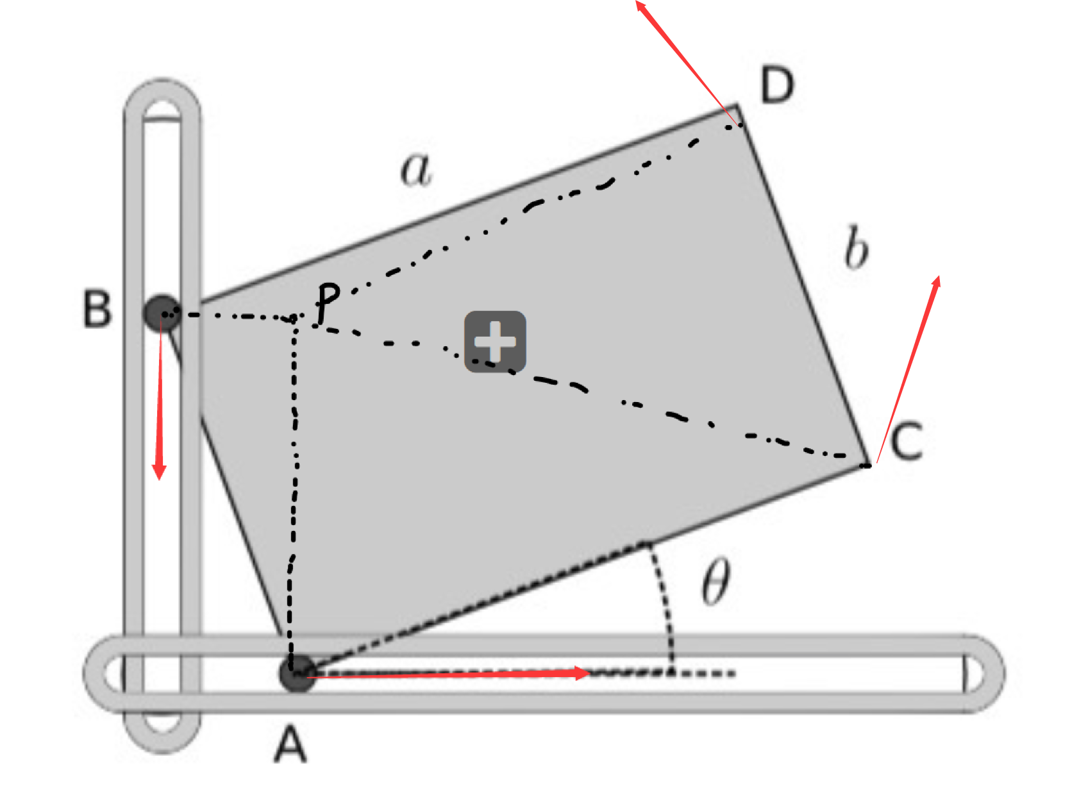
- We have the following relation
$$v_{B}=-v j$$
$$v_{B}=ω ×\overline{PB}=ω×(-b\sin{θ} i)$$
Thus we have
$$-v j= ω×(-b\sin{θ} i)$$
Since we know $ω$ must be in the z-direction (the rotation is planar in x-y plane), we have
$$ω=\frac{v}{b\sin{θ}} k$$
- We have
$$v_{C}=ω ×\overline{PC}=\left(\frac{v}{b\sin{θ}} k\right)×\left(a\cos{θ} i-\left(b\cos{θ}-a\sin{θ}\right)j\right)$$
$$=\frac{v}{b\sin{θ}}\left(b\cos{θ}-a\sin{θ}\right)i+\frac{va\cos{θ}}{b\sin{θ}} j$$
- As we have mentioned in (a) that the actual magnitude of velocities (i.e., speed) at A, B, C, D are proportional to lengths of $PA, PB, PC, PD$. This is because
$$v_{X}=ω ×\overline{PX}$$
where $X$ can be $A,B,C,D$, and since $ω$ is always perpendicular to $\overline{PX},$we have
$$v_{X}=ω|PX|$$
which proves our claim. It is obvious that the moment $\left|PC\right|=\left|PD\right|$ is when $θ=π/2$
- The magnitude of angular velocity $ω$ in terms of $v_{A}$is
$$v_{A}=ωb\cos{θ}$$
Take derivative of both sides to get
$$0=a_{c}=\dot{v_{A}}=b(α\cos{θ}-ω\sin{θ}ω)$$
where we have used the product rule and chain rule, as well as the definition $\dot{θ}=ω, \dot{ω}=α$
Thus, we have
$$α=ω^{2}\tan{θ}={\left(\frac{v_{A}}{b\cos{θ}}\right)}^{2}\tan{θ}$$
For $θ∈[0,π/2]$, the acceleration is always positive (anticlockwise).

