- We can easily show that the probability of getting $HH$ in finite time is 1. The probability of getting two consecutive $H$ is 1/2 times 1/2, which is 1/4. Thus, the probability of never getting $HH$ is $\lim_{n→∞}{{\left(1-\frac{1}{4}\right)}^{n}}→0$, which shows that its complement event (getting $HH$ in finite time) is $1-0=1$.
- We use 1-5 to represent the five states described in the problem. Now, the one-step transition matrix is obtained in the following way:

We have $p_{11}=1$ and $p_{21}=1$ while all other $p_{1k}, p_{2k}$ are 0, because the game stops whenever it enters these two states, and they can be treated as absorbing states.

We have $p_{31}=1/2$ because once the last letter is $H$, we have 1/2 probability of getting another $H$ and end the game in state 1. $p_{33}=0$ because it is self-contradictory. $p_{34}=1/2$ because we have 1/2 probability of getting a $T$ and enters state 4. $p_{35}=0$ is impossible because we have the last letter $H$, and cannot have $TT$.

Through similar reasoning, we can have $p_{41}=0$, $p_{42}=1/2$, $p_{43}=1/2$, $p_{44}=0$, $p_{45}=0$ and $p_{51}=0$, $p_{52}=0$, $p_{53}=1/2$, $p_{54}=0$, $p_{55}=1/2$.

The first three outcomes were $TTT$, so it means that we are staring from state 5. From the transition diagram below, we see that we must go from state 5 to state 3 before absorbed by either state 1 or 2. It makes sense because if we want to get $HH, HTT$, we must have a flip that starts with $H$ (i.e., enter state 3). Thus, without loss of generality we may suppose the system starts in state 3.
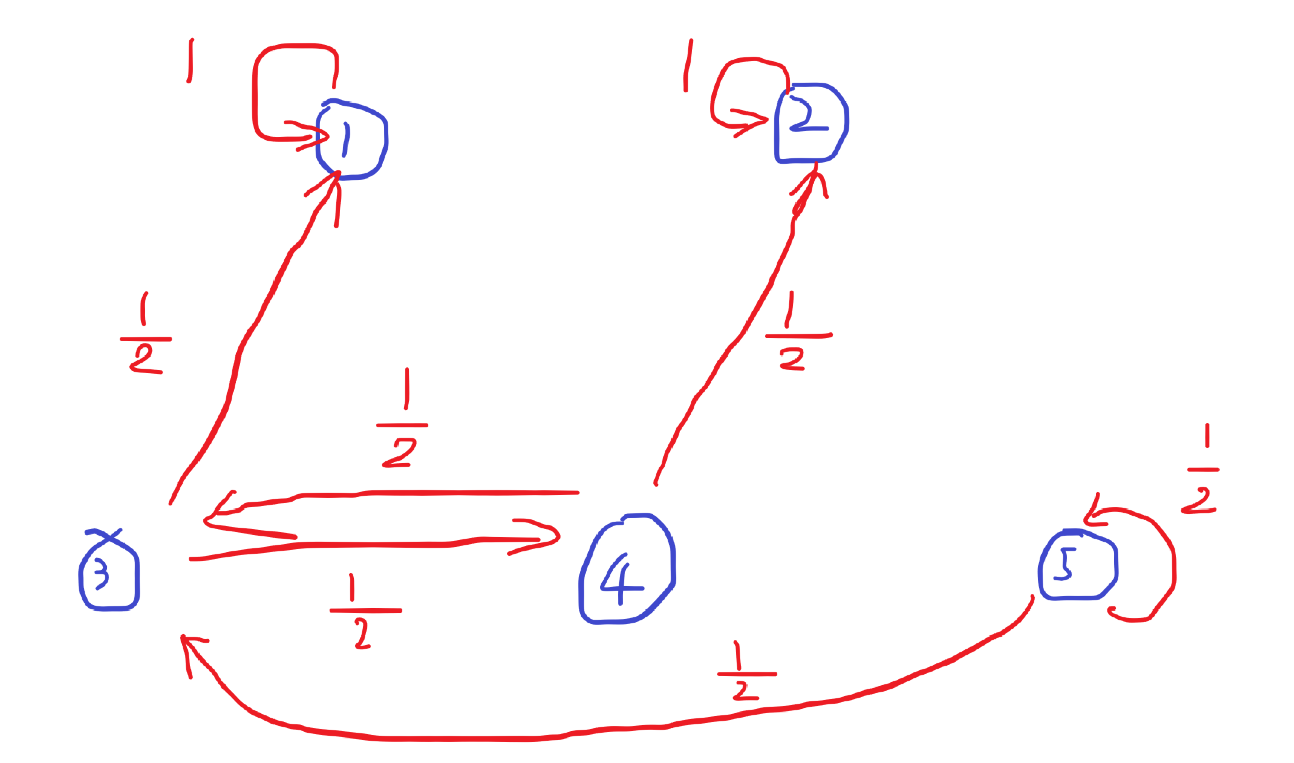
Denote by $p$the probability that we are absorbed by state 1 (i.e., Chun sees $HH$ before $HTT$), we have, by total probability rule, we have
$$p=\frac{1}{2}+\frac{1}{2}×\frac{1}{2}p$$
In the equation above, the first 1/2 is the probability of entering state 1 directly from state 3, while the second part denotes the probability of first entering state 4 (which gives a factor of 1/2), then getting back to state 3 (another 1/2), and finally being absorbed into state 1 (which has probability $p$ as we define it in this way). Thus, we easily solve out $p=\frac{2}{3}$.
- Denote by $X$ the random variable of total number of flips needed to be absorbed and $E(X|k)$ by the conditional expectation of $X$ given the condition that we are in state $k$, we have
$$E\left(X|5\right)=1+\frac{1}{2}E\left(X | 5\right)+\frac{1}{2}E(X|3)$$
$$E\left(X | 3\right)=1+\frac{1}{2}E(X|4)$$
$$E\left(X | 4\right)=1+\frac{1}{2}E\left(X | 3\right)$$
We solve out $E\left(X | 3\right)=2, E\left(X | 4\right)=2$, $E\left(X | 5\right)=4$. The expected time we are looking for is $E\left(X | 5\right)=4$ because we start with $TTT$ (in state 5).

