Are visual representations always helpful in the communication of knowledge?
Defination: The definitions of Zimmermann and Cunningham (1991, p. 3) and Hershkowitz et al. (1989, p. 75) to propose that: Visualization is the ability, process and product to create, explain, use and reflect on pictures, images, charts in our minds, on paper or in technical tools. The purpose is to describe and exchange information, think and develop previously unknown ideas, and improve understanding.
Visual representations range from simple maps and schematics to computer generated 2D and 3D visualization. They are different from other types of representations, such as sentence representations, because they use visual variables to convey information to users. On the contrary, sentences express the use of the semantics of their constituent units, words and letters to achieve the same purpose. Therefore, the meaning of a word depends on its context and letters, not on its spatial location. (Görg, C., Pohl, M., Qeli, E., Xu, K. (2007). Visual Representations. In: Kerren, A., Ebert, A., Meyer, J. (eds) IH uman-Centered Visualization Environments. Lecture Notes in Computer Science, vol 4417. Springer, Berlin, Heidelberg.)
One way of characterizing visualization and its importance, both as a ‘noun’ – the product, the visual image – and as a ‘verb’ – the process, the activity – (Bishop, 1989, p. 7), is that ‘Visualization offers a method of seeing the unseen’ (McCormick et al., 1987, p.3). Visual representations are widely used in communication to convey information in a recognizable form that can be easily interpreted without resorting to tedious computations. The types of visual representations occur in six types: graphs, tables, maps, diagrams, networks and icons. The variations on these types can also be classified according to the way they convey information and the efficiency in which they provide information. (GL Lohse, K Biolsi, N Walker, HH Rueter - Communications of the ACM, 1994)
Examples: The following example is a chart, considered a classic of data graphing, designed by Charles Joseph Minard (1781–1870), a French engineer.
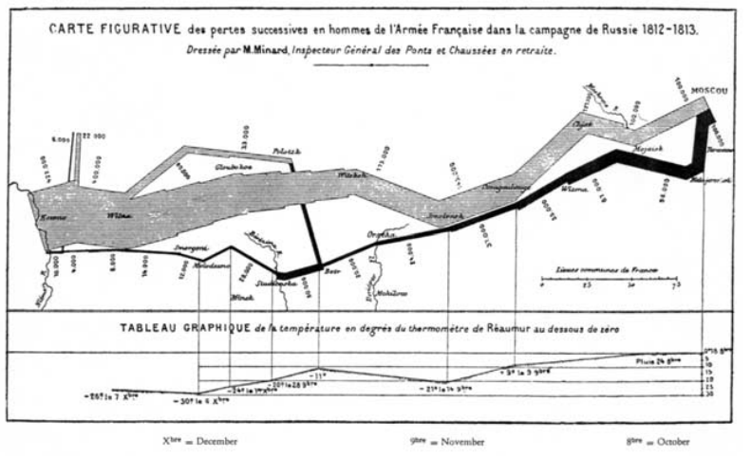
Figure 1 A chart describing Napoleon’s 1812 Russian campaign.
This picture depicts Napoleon's devastating losses in the Russian War of 1812. The two-dimensional graph tells the "whole" story by displaying six variables: the size of the army, the exact (two-dimensional) position, direction, temperature and date, and condenses the global information in a compact way.Visual display enables us to "see" the story, imagine some causality, and possibly remember it vividly. This chart is certainly an example of the "chart value of one thousand (or" ten thousand ") words", because a) their two-dimensional and nonlinear organization, rather than "printed words" emphasizing sequence and logical elaboration; b) They combine information clusters, similar to what we see in daily life, to help "reduce knowledge search" and make data "easy to perceive".
Another example is in the field of mathematics. Anscombe (1973, p. 17) claims that ‘Graphs can have various purposes, such as: (i) to let us perceive and appreciate some broad features of the data, (ii) to let us look behind those broad features and see what else is there’. And he presents an example of four sets of data (Figure 2) that can be characterized by a set of identical parameters (Figure 3) and which looks quite different when the data are plotted (Figure 4):
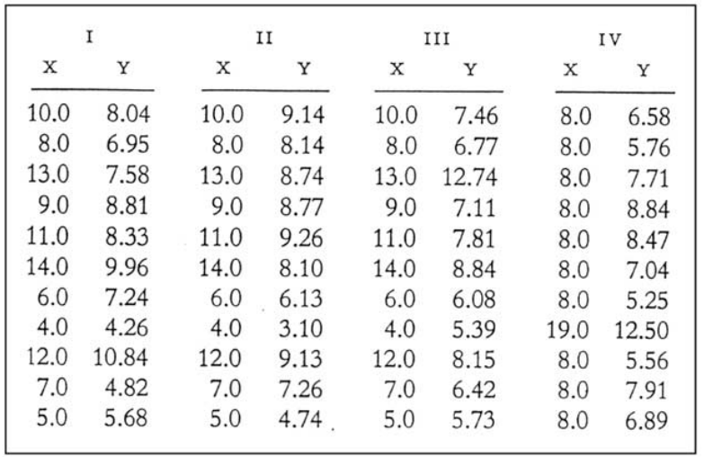
Figure 2
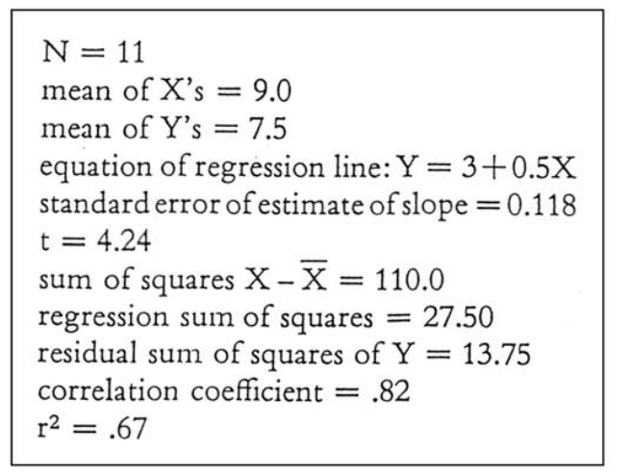
Figure 3
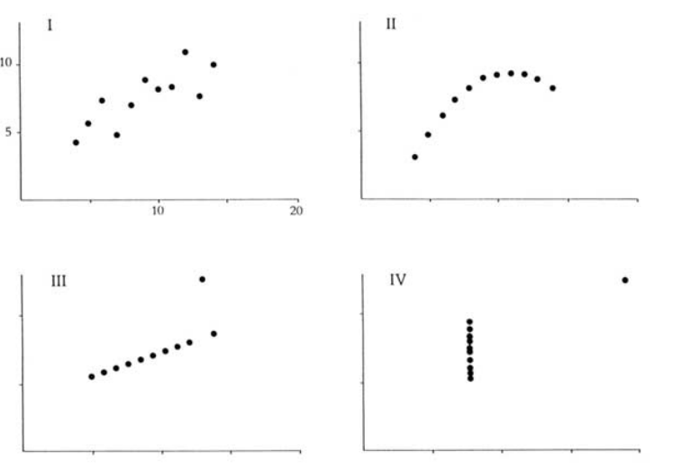
Figure 4
In this case, the graphic display may support the expansion of the data sleep feature (hidden in the same and opaque parameters), because it is not just a description. As Taft said, in this case, "figures show data. In fact, figures can be more accurate and revealing than traditional statistical calculations".
Conclution: Visualization really plays an irreplaceable role in the transmission of information. It allows us to better understand the information, more intuitively interpret the meaning of the author, and more clearly convey the information to others

