We notice that the definition of Cantor set is equivalent to taking out every middle one-third part of the black bars in the diagram. For instance,
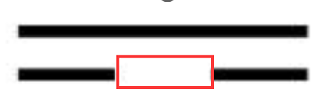
The second set is obtained by taking out the middle $\left(\frac{1}{3},\frac{2}{3}\right)$ part of the first set (the red one), and the third set is taking out the middle of the first part in the second set (the blue part) and the middle of the second part (the green part)
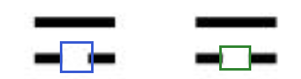

Uncountable: We first show that it is uncountable by finding a surjective function from the Cantor set $C$ to the closed interval $[0, 1]$. For this construction, we represent points in $[0, 1]$ by ternary notation (i.e., in the base 3). In this notation, $1/3$ is represented by ${0.1}_{3}$, since
$$0×3^{0}+1×3^{-1}=\frac{1}{3}$$
and similarly $2/3={0.2}_{3}$. We can see that the first part removed in the processes of construction of Cantor set (the red part below) contains all points in $\left(\frac{1}{3},\frac{2}{3}\right)$, and in ternary representations, those points all have the form $0.1{xxxx}_{3}…$ where $xxxx…$ are between $0000…$ and $2222…$ Thus, when we take out the red part, we are taking away all points with 1 at the first decimal place in the ternary representation
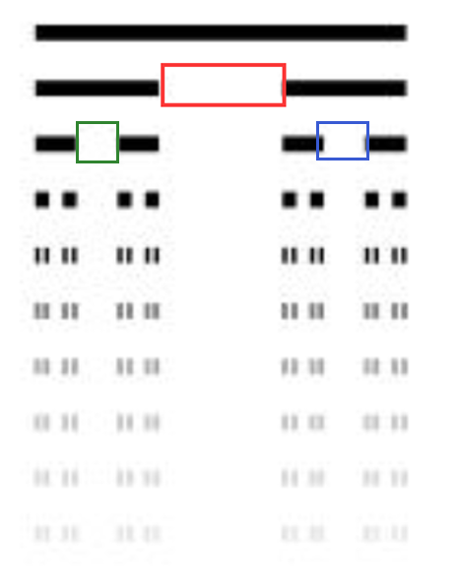
Similarly, when we cut out the green and blue part, we are, in the ternary representation, taking away points of the form $0.01{xxx}_{3}…$ or $0.21{xxx}_{3}…$ where $xxxx…$ are still arbitrary between $0000…$ and $2222…$ Thus, we take away all points with 1 at the second decimal places.

By induction, we see that when we construct the $(n+1)$-th set from the $n$-th set, we are taking out all points with the $n$-th decimal point being 1. Thus, the final Cantor set contains every point of the form $0.{xxxxxxxx}_{3}$ where $x$ at each decimal place can be taken from $\{0, 2\}$ arbitrarily. Then, for every point in the Cantor set, we first rewrite it in the ternary form $0.{xxxxxxxx}_{3}$, then change every 2 in the expression into 1, and evaluate this number in binary form.
For instance, if the number is ${0.2202}_{3}$, we evaluate it as ${0.1101}_{2}$ (we change all 2 into 1, and evaluate in the binary base). Obviously, this process is actually a surjection from the Cantor set to $[0, 1]$. Since every point in $\left[0, 1\right]$ has a unique binary representation $0.{xxxxxxxx}_{2}$ where every $x$ can be taken from $\{0, 1\}$. Thus, we have more elements in the Cantor set than in $[0, 1]$, but on the other hand, the cardinality of the Cantor set cannot be greater than that of $[0, 1]$. Thus, we claim that the cardinality of the Cantor set is the same as that of $[0, 1]$, which is uncountable.

Closed: Since the Cantor set is the intersection of closed sets, it is automatically closed.

Codense: We prove by contradiction. If it is not condense, the interior is not empty, which means we can find at least one element $a$ in its interior. By definition of interior, there is at least one open interval $I$ that covers that point $a$. Since the length (Lebesgue measure in strict mathematical language) of the interval is $\left|I\right|>0$, we can have a contradiction, since $I∩C^{c}=∅$ (the interior of a set has empty intersection with the complement of that set), the length of the set $I∪C^{c}$ is equal to the sum of the length of $I$ and $C^{C}$ respectively. However, from the construction of Cantor set, we see that $C^{C}$ has length
$$\left|C^{C}\right|=\sum_{n=1}^{∞}{\frac{2^{n-1}}{3^{n}}}=1$$
But $\left|I\right|>0$, so $\left|I∪C^{c}\right|=\left|I\right|+\left|C^{c}\right|>1$. However, since the total length of $[0, 1]$ is 1, it is impossible to have $\left|I∪C^{c}\right|>1$, a contradiction.

Final property: We will base this proof on the last codense property. Notice that the condense property means that for any given different points $a,b∈C$ such that $a<b$, there is a point $c$ that lies in between and does not belong to the Cantor set, i.e., $a<c<b$ and $c∈C^{C}$. Now, suppose there is an $x∈C$ and an open set $U⊂C$ with $x∈U$. By definition of subspace topology, it means an open set $U'$ in $\left[0, 1\right]$ that covers $x$ and $U^{'}∩C=U$. Without loss of generality, we take $U'$ to be an interval $(a',b')$. We can do this because every open set in $[0, 1]$ can be written in terms of union of open intervals, and at least one of these intervals contain the fixed $x$. Now, we shorten the interval $\left(a^{'},b^{'}\right)$ into $(a,b)$ the following way: if $a^{'}∉C$, we keep $a=a'$ as it is now, while if $a^{'}∈C$, by what we have discussed at the beginning, there is a number $a$ that lies between $a^{'}, x$ such that $a∉C$. For $b'$, we do the same thing: if $b^{'}∉C$, $b=b'$, while if $b'∈c$, there is a number $b$ that $x<b<b'$ and $b∉C$. Then, we obtain an interval $(a,b)$ such that it contains $x$, and its two endpoints $a,b$ are both not in the Cantor set. Thus, the intersection of $(a,b)$ with $C$ is the same as the intersection of its closed version $[a, b]$ with $C$, since the endpoints are not in $C$.
Now, we can denote
$$V≔\left(a,b\right)∩C=\left[a,b\right]∩C$$
From this definition, we see $V$ is both open and closed in $C$, and $x∈V$, and
$$V=\left(a,b\right)∩C⊂\left(a^{'},b^{'}\right)∩C=U$$

