- Answer:
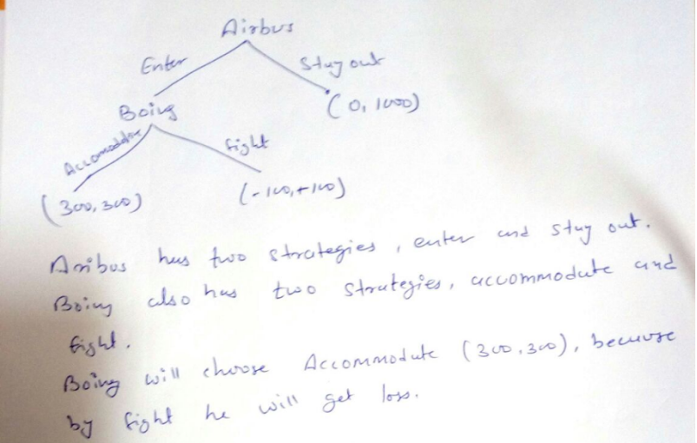
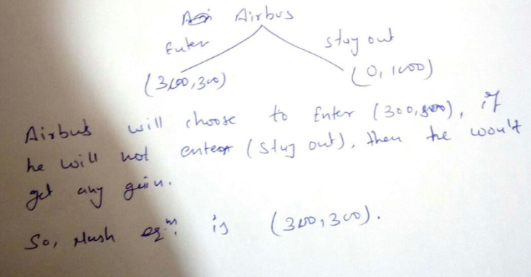

- Answer:
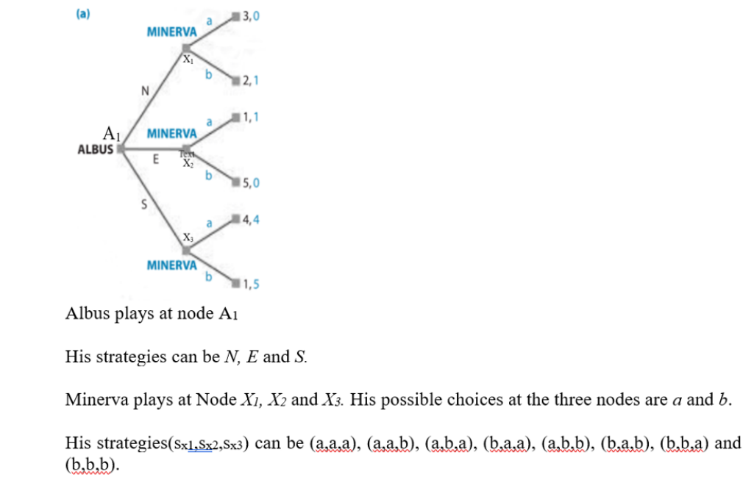
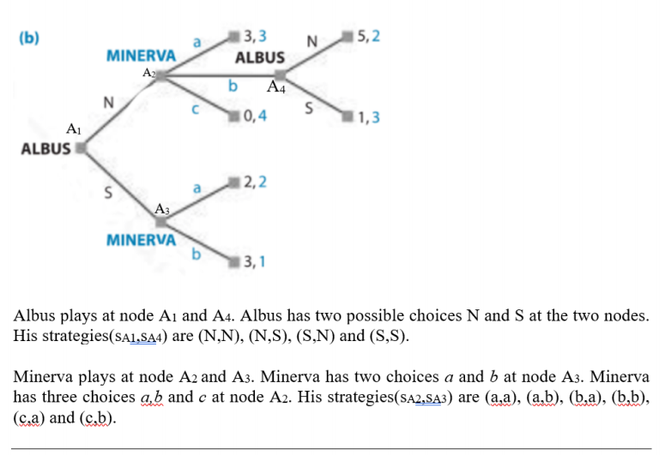
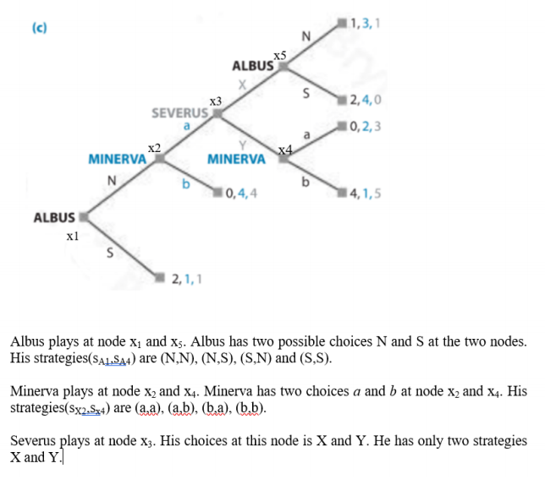

- Answer
PART-a:
Strategy lists are as follows: 1) Albus: N; M; S. 2) Minerva: aaa, aab, aba, abb, baa, bab, bba, bbb
Thus, the rollback equilibrium outcome is that Albus plays N & Minerva plays b. The complete equilibrum strategy for Albus is N and for Minerva is bab.
PART-b:
Strategy lists are as follows: 1) Albus: NN; NS; SN; SS. 2) Minerva: aa, ab, ba, bb, ca, cb.
Thus, the rollback equilibrium outcome is that Albus plays S and then Minerva plays a. The complete equilibrium strategy of Albus is SN and equilibrium strategy for Minerva is ca , i.e C at upper node and a at lower node.
PART-c:
Strategy lists are as follows: 1) Albus: NN; NS; SN; SS. 2) Minerva: aa, ab, ba, bb. 3) Severus: X; Y.
Thus, the rollback equilibrium outcome is that Albus plays S. The complete equilibrium strategy of Albus is SS, equilibrium strategy for Minerva is ba, and equilibrium strategy for Severus is Y.

