Question 1
Coffee S.A. signed a contract with S&E Leasing Company at 1st January 2022 to lease specialized equipment to make coffee. The agreement consists in 12 equal annual payments of $180,000 at the beginning of each year with an interest rate of 10%. The yearly rental payment includes $20,000 of executory costs related to insurance on the equipment. The executory costs are paid to the lessor each year. There is an option to purchase the machine at the end of the lease term for $40,000. The equipment has an estimated useful life of 15 years and a guaranteed residual value of $30,000. Both companies adopt straight-line depreciation method for all items of PPE. Consider a PVIF (n=12, i=10%) of 0.3186 and PVIFA (n=12, i=10%) of 6.8137. The balance day for both companies is 31 of December.
Required
a) Discuss the nature of this lease to Coffe S.A.
Leasing is an arrangement under which an entity acquires the right to control the use of an underlying asset for a period of time in exchange for consideration. In this case, Coffe S.A. is the lessee, and S&E Leasing Company is the lessor.
There are two types of leases, operating leases and finance leases. According to NZ IFRS 16 Leases paragraph 62, a lease is classified as a finance lease if it transfers substantially all the risks and rewards incidental to ownership of an underlying asset. It is a finance lease if at least one of the following finance lease criteria is met:
(a) the lease transfers ownership of the underlying asset to the lessee by the end of the lease term;
(b) the lessee has the option to purchase the underlying asset at a price that is expected to be sufficiently lower than the fair value at the date the option becomes exercisable for it to be reasonably certain, at the inception date, that the option will be exercised;
(c) the lease term is for the major part of the economic life of the underlying asset even if title is not transferred;
(d) at the inception date, the present value of the lease payments amounts to at least substantially all of the fair value of the underlying asset; and
(e) the underlying asset is of such a specialised nature that only the lessee can use it without major modifications.
From the lease contract in this case, the lease term is 80% (12/15) for the asset's estimated useful life, which is for the major part (75% or greater) of the economic life of the underlying asset. Based on that, this lease transfers substantially all the risks and rewards incidental to ownership of an underlying asset to the lessee and therefore this lease qualifies as a finance lease to Coffe S.A.

b) Calculate the present value of the minimum lease payment.
Be sure to show your workings.
present value of the minimum lease payment
=annual lease payment×PV factor¹ + residual value×PV factor²
=($180,000-$20,000)×(6.8137-0.3186) + $30,000×0.3186=$1,039,216 + $9,558 =$1,048,774
Note 1: PV factor¹= PVIFA (n=11, i=10%)= PVIFA (n=12, i=10%) - PVIF (n=12, i=10%)=6.8137-0.3186=6.4951 (payment in advance)
PV factor²= PVIF (n=12, i=10%)=0.3186
Note 2: executory costs are not included in the minimum lease payment.

Question 2
Food Delivery Limited is involved in three different lease situations. Each of these leases is non-cancellable and in no case does Food Delivery Limited receive title to the properties leased at the end of the lease term. All leases started on 1 January 2021, with the first rental payment due at the beginning of the year. Additional information about each lease is as follows. Balance day is 31 December.
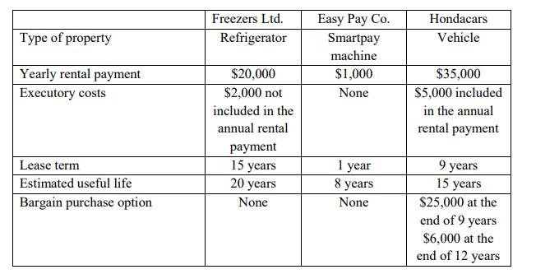
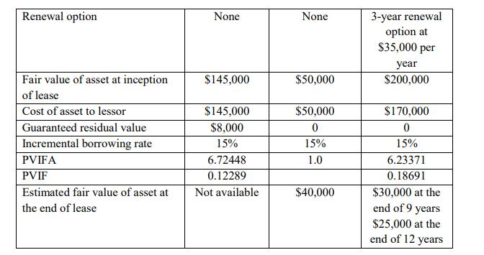
Required
For each lease:
a) Indicate the type of lease from the lessor’s point of view.
(1) Freezers Ltd.: The present value of the minimum lease payment is $115,472.72 ($20,000×(6.72448-1)+$8,000×0.12289), 79.64%($115,472.72/$145,000) of the fair value of the underlying asset at the inception date. Although that is lower than 90%, the lease term is 75% (15/20) for the asset's estimated useful life, which is for the major part (75% or greater) of the economic life of the underlying asset. Thus, the lease qualifies as a finance lease because it transfers substantially all the risks and rewards incidental to ownership of an underlying asset.
(2) Easy Pay Co.: The lease does not transfer ownership of the underlying asset to Food Delivery Limited by the end of the lease term. The lease term is 12.5% (1/8) for the asset's estimated useful life, lower than 75% of the estimated useful life. This is a 12-month lease contract without any purchase option or renewal option. At the inception date, the present value of the lease payments does not amount to at least substantially all of the fair value of the underlying asset. And there is no indicator presenting that the underlying asset is of such a specialised nature that only the lessee can use it without major modifications. This lease does not meet any of the finance lease criteria. Since it is a short-term lease contract of low value, actually it can be exempted from lease recognition.
(3) Hondacars: The lease term is 60% (9/15) for the asset's estimated useful life, lower than 75% of the estimated useful life. However, the fair market value of an asset at the end of 9 years is estimated at $30,000, but the lease agreement has an option that enables the lessee to purchase it for $25,000, which is lower than the fair market value. And at the end of 12 years the lease agreement has an option that enables the lessee to purchase it for $6,000 which is substantially below the fair market value $25,000 at the end of 12 years. It is considered that Food Delivery Limited has an economic incentive to exercise the purchase option at the end of 12 years because it could bring more benefit for Food Delivery Limited compared with the purchase option at the end of 9 years. This would be considered a bargain purchase option and would require the lessor to treat the lease as a finance lease.

b) Record the journal entries at inception of the lease for the lessee and lessor.
The present value of the minimum lease payment is $115,472.72 ($20,000×(6.72448-1)+$8,000×0.12289), 79.64%($115,472.72/$145,000)
(1) Freezers Ltd.:
Lessee: Dr Right-of-use asset $135,472.72
Cr Lease liability $115,472.72 ($20,000×(6.72448-1)+$8,000×0.12289)
Cr Bank $20,000 (payment in advance)
Dr Executory cost (expense) $2,000
Cr Bank $2,000
Lessor: Dr Lease Receivable $115,472.72
Dr Bank $20,000
Dr Loss on asset disposal $9,527.28 ($145,000-$135,472.72)
Cr Refrigerator (PPE) $145,000
Dr Bank $2,000
Cr Lease revenue $2,000
(2) Easy Pay Co.:
Lessee: Dr Lease expense $1,000
Cr Bank $1,000 (payment in advance)
Lessor: Dr Bank $1,000
Cr Lease revenue $1,000
(3) Hondacars:
Lessee: Dr Right-of-use asset $188,132.76
Cr Lease liability $158,132.76 ($30,000×(6.23371-1) +$6,000×0.18691)
Cr Bank $30,000 (payment in advance)
Dr Executory cost (expense) $5,000
Cr Bank $5,000
Lessor: Dr Lease Receivable $158,132.76
Dr Bank $30,000
Cr Refrigerator (PPE) $170,000
Cr Gain on asset disposal $18,132.76 ($188,132.76-$170,000)
Dr Bank $5,000
Cr Lease revenue $5,000

c) Name who is recognising the asset depreciation adjusting entry and the period selected for calculation. Be sure to show your workings. Narrations are not required.
For the lease contracts with Freezers Ltd. and Hondacars, the lessee, Food Delivery Limited is recognising the asset depreciation adjusting entry since these two leases are finance leases. For the lease contract with Freezers, since there is no reasonable certainty that the lessee will obtain ownership by the end of the lease term, the asset shall be fully depreciated over the shorter of the lease term and its useful life, which is the lease term 15 years. For the lease contract with Hondacars, since Food Delivery Limited has an economic incentive to exercise the purchase option at the end of 12 years which indicates that there is reasonable certainty that the lessee will obtain ownership by the end of the lease term, the asset shall be fully depreciated over its useful life, which is 15 years.
For the lease contract with Easy Pay Co., the lessor should recognize the asset depreciation adjusting entry and depreciate the asset over its estimated useful life, which is 8 years.

Question 3
On May 2020, Corporation International S.A. issued a prospectus inviting the public to subscribe for 5 million ordinary shares of $5.0 each. The company, listed on the New Zealand Stock Exchange, requested that the issue price be paid in three parts, these being $2.0 on application, $2.0 within two months of the shares being allotted and $1.0 within five months following allotment. Applications were received for 7 million shares during May 2020.
The directors allotted 5 million shares on 31 May 2020. All applicants received shares on a pro rata basis. The amounts payable on allotment were due by 31 July 2020 for call one and 31 October 2020 for call two. By 31 October 2020, the holders of 1 million shares had failed to pay the amounts due on allotment. The directors considered the shares forfeit on 15 November 2020. Subsequently, the shares were resold on 30 November 2020 as fully paid and an amount of $4.5 per share was received. The cost of reissuing the shares amounted to $100,000.
Required
a) Provide the journal entries necessary to account for the above transactions.
(1) During May 2020; On receipt of application money
Dr Bank $14m (7m shares×$2.0)
Cr Share application $14m
(Being application money received for 7m shares@ $2.0 each)
(2) @31 May 2020; Transfer of application money to share capital account
Dr Share application $14m
Cr Share capital $10m (5m shares×$2.0)
Cr Share allotment $4m
(Share application money of 5m shares transferred to share capital @ $2.0 each and $4m adjusted towards allotment)
(3) @31 July 2020; Share allotment for call one due
Dr Share allotment (call one) $10m (5m shares×$2.0)
Cr Share capital $10m
(Being share allotment for call one due on 5m shares @ $2.0 each)
@31 July 2020; Share allotment money received
Dr Bank $8.8m (5m shares×$2.0-$1.2m(W1))
Cr Share allotment $8.8m
(4) @31 October 2020; Share allotment for call two due
Dr Share allotment (call two) $5m (5m shares×$1.0)
Cr Share capital $5m
(Being money on share allotment for call two due on 5m shares @ $1.0 each)
@31 October 2020; Share allotment money received
Dr Bank $3.8m (5m shares×$1.0-$1.2m(W1))
Cr Share allotment $3.8m
(5) @15 November 2020; Share forfeited
Dr Share capital $5m (1m shares×$5.0)
Cr Share allotment (call one) $1.2m (W1)
Cr Share allotment (call two) $1m (1m shares×$1.0)
Cr Share forfeiture $2.8m (W2)
(1m shares forfeited for non-payment of allotment for call one and call two)
W1: Shares allotted to the holders who had failed to pay the amounts due on allotment=1m
Shares applied by the holders above=1m×(7m/5m)=1.4m shares
Money received on application=1.4m shares × $2.0=$2.8m
Less: Money transferred to share capital=1m shares × $2.0=$2m
Excess money received on application=$2.8m-$2m=$0.8m
Allotment due=1m shares × $2.0=$2m
Less: Excess money on Application=$0.8m
Calls-in arrears on allotment=$1.2m
W2: Share forfeiture of 1m shares=1.4m×$2.0=$2.8m
(6) @30 November 2020; Shares reissued
Dr Bank $4.5m (1m shares×$4.5)
Dr Share forfeiture $0.5m
Cr Share capital $5m (1m shares×$5)
(1m shares reissued @ $4.5 per share)
@30 November 2020; The cost of reissuing
Dr Reissuing expense $100,000
Cr Bank $100,000
@30 November 2020; Balance in share forfeiture transferred to capital reserve
Dr Share forfeiture $2.3m ($2.8m-0.5m)
Cr Capital reserve $2.3m
b) Provide the journal entry in the case Corporation International S.A. would not be listed on the New Zealand Stock Exchange or not have any policy regarding refunds. Be sure to show your workings. Narrations are not required.
Balance sheet of Corporation International S.A. after issuing the prospectus
Share capital $25m (5m shares×$5.0)
Capital reserve $2.3m
Cash and cash equivalents $31m

When Corporation International S.A. would not be listed on the New Zealand Stock Exchange or not have any policy regarding refunds, Corporation International S.A. can buy its own shares back either from the free reserves, securities premium or from the proceeds of any shares or other specified securities. If the shares are bought-back out of free reserves:
Dr Share capital $25m
Dr Capital reserve $2.3m
Cr Bank $27.3m
Dr Capital reserve $25m
Cr Capital redemption reserve $25m

