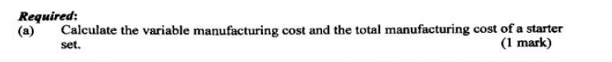

Variable manufacturing cost= 20+30+10+40+8*2=116
Total=Variable + Fixed =116+12*2=140

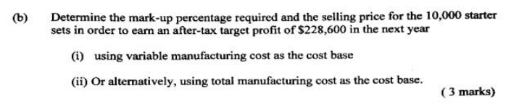
- (116X*10000-5*10000-24*10000-20000) *(1-28%)=228600
X=54.09% selling price=116*(1+54.09%)=178.74

- (140*10000*Y-5*10000-20000)*(1-28%)=228600
Y=27.68% selling price=140*（1+27.68%）=178.752

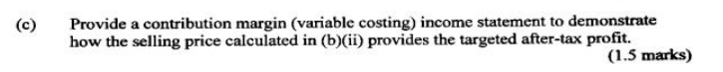

Sales |  | 1400000*(1+Y)
Less variable expenses
Direct material(20+30+10) | 60*10000=600000
Direct Labor | 40*10000=400000
Variable manufacturing overhead(8*2) | 16*10000=160000
Total variable manufacturing cost |  | 1160000
Variable selling expenses | 5*10000 | 50000
Contribution margin |  | 190000+1400000Y
Less fixed expenses:
Fixed manufacturing overhead  (12*2) | 24*10000=240000
Fixed selling and admin expenses | 20000
Total fixed expense |  | 260000
Total manufacturing costs | 1400000
Operating income |  | 1400000Y-70000
Tax(28%) |  | (1400000Y-70000)*28%
Profit after tax  (Y=27.68%) | (1400000Y-70000)*0.72=228600 | 228600
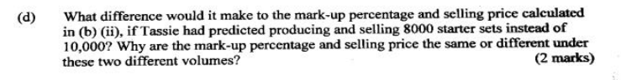

Sales |  | 140*(1+Y)*8000
Less variable expenses
Direct material(20+30+10) | 60*8000=480000
Direct Labor | 40*8000=320000
Variable manufacturing overhead(8*2) | 16*8000=128000
Total variable manufacturing cost |  | 928000
Variable selling expenses | 5*8000 | 40000
Contribution margin |  | 152000+1120000Y
Less fixed expenses:
Fixed manufacturing overhead  (12*2) | 24*8000=192000
Fixed selling and admin expenses | 20000
Total fixed expense |  | 212000
Total manufacturing costs | 1120000
Operating income |  | 1120000Y-60000
Tax(28%) |  | (1120000Y-60000)*28%
Profit after tax  (Y=33.70%) | (1120000Y-60000)*0.72=228600 | 228600

As we can see , when selling volume changes to 80,000 the mark-up will increase to 33.7% and the selling price will also change to 140*(1+33.7%)=187.18.
The reason why the mark-up increases due to the decline of the sales volume is that to achieve a certain profit, the more products we sell, the lower cost per unit we will achieve, and the mark-up will be required less, as we already achieve a lower cost which lead to a higher margin.


The total manufacturing cost method includes fixed manufacturing overheads in the cost of the product, which is only gradually released as sales of the product are realised. In other words, fixed manufacturing overheads are allocated to sales as they are incurred. This pricing method is not only easy to implement, but also allows for full cost recovery and provides the business with a certain level of profit, in this case, it’s a good idea to use this method.
However, unlike under the variable cost method, fixed manufacturing overheads are recognised directly in profit or loss, which means that they are recognised as an expense in the period in which they are incurred, irrespective of the volume of sales. It Facilitates the correct evaluation of performance between periods and simplifies costing and avoids subjective arbitrariness in the apportionment of fixed costs.

