$$\frac{dS}{dt}=-βSI,$$
$$\frac{dI}{dt}=βSI-rI,$$
$$\frac{dR}{dt}=rI.$$
$$S_{0}=N-1, I_{0}=1, R_{0}=0$$
- $r=\frac{1}{7}, β=\frac{R_{0}r}{N}=\frac{4.5}{7×5x{10}^{6}}=1.29×{10}^{-7}$
- $S_{m}=\frac{r}{β}=\frac{N}{R_{0}}, I_{m}=-S_{m}+I_{0}+S_{0}+S_{m}\ln\left(\frac{S_{m}}{S_{0}}\right)=2.22×{10}^{6}$
- About 58550 people can avoid an infection.
R CODE
library(deSolve)
library(ggplot2)
library(tidyverse)
theme_set(theme_minimal())

N <- 5e6
R0 <- 4.5
parms <- c(beta=R0/7/N, r=1/7)
inits <- c(S=N-1, I=1, R=0)
dt <- seq(0,200,0.1)

SIR <- function(t, x, parms){
with(as.list(c(parms,x)),{
dS <- - beta*S*I
dI <- + beta*S*I - r*I
dR <- r*I
der <- c(dS, dI,dR)
list(der) # the output must be returned
}) # end of ’with’
} # end of function definition

simulation <- as.data.frame(lsoda(inits, dt, SIR, parms=parms))
min(simulation$S) # the answer
# plot
df <- simulation %>%
gather(key = "Type", value = "Number", -time)
colnames(df) <- c("Days", "Type", "Number")

ggplot(df, aes(x = Days, y = Number)) +
geom_line(aes(color = Type)) +
scale_color_manual(values = c("darkred", "steelblue", "darkgreen"))
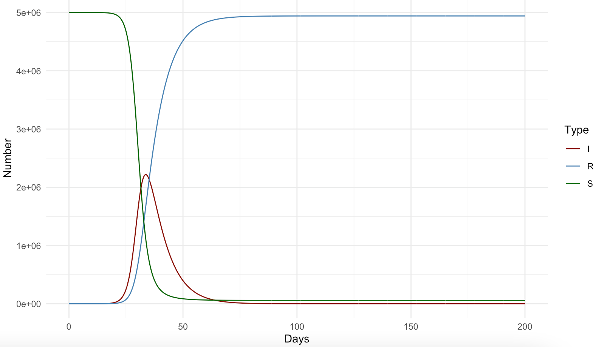
- $r=\frac{1}{3}$. Isolation is assumed to reduce $β$ by 30% due to less connection rate.
- $R_{0}=\frac{βN}{r}=1.29×{10}^{-7}×0.7×5×{10}^{6}×3=1.35$
- $S_{m}=\frac{r}{β}=\frac{N}{R_{0}}, I_{m}=-S_{m}+I_{0}+S_{0}+S_{m}\ln\left(\frac{S_{m}}{S_{0}}\right)=1.85×{10}^{5}$
- About 2654165 people will have escaped an infection.
R CODE
library(deSolve)
library(ggplot2)
library(tidyverse)
theme_set(theme_minimal())

N <- 5e6
R0 <- 4.5
parms <- c(beta=R0/7/N*0.7, r=1/3)# isolation
inits <- c(S=N-1, I=1, R=0)
dt <- seq(0,200,0.1)

SIR <- function(t, x, parms){
with(as.list(c(parms,x)),{
dS <- - beta*S*I
dI <- + beta*S*I - r*I
dR <- r*I
der <- c(dS, dI,dR)
list(der) # the output must be returned
}) # end of ’with’
} # end of function definition

simulation <- as.data.frame(lsoda(inits, dt, SIR, parms=parms))
min(simulation$S)# the answer

# plot
df <- simulation %>%
gather(key = "Type", value = "Number", -time)
colnames(df) <- c("Days", "Type", "Number")

ggplot(df, aes(x = Days, y = Number)) +
geom_line(aes(color = Type)) +
scale_color_manual(values = c("darkred", "steelblue", "darkgreen"))
